Requirements | Role Details
Directorate: | Community Wellbeing
Grade: | HC09
Location: | Plough Lane, Hereford, HR4 OLE/ Remote
Responsible to: | Team Manager (Occupational Therapist)

Job Description

Job Role: Senior Practitioner Occupational Therapist
Service: Independent Living Service

Main purpose of the role

The senior practitioner provides a leadership and line management role within the Independent Living Services Occupational Therapy team managing a small group of staff and holds a nominal caseload of people with complex needs.

A senior practitioner in their day to day will focus on quality assuring those they line manage, ensuring standards of professional practice are being met, by providing supervision, case management oversight and personalised support; promoting staff development and ensuring standards of professional practice are maintained.

Our priority is prevention. Through skills, knowledge and integrated practice the senior practitioner applies holistic, strengths-based approach to undertake complex needs assessments, identify risks and make appropriate decisions about available options to promote independence in daily activities and enable individuals, families and carers choice and access to available support to lead safe, independent lives.

Senior Practitioners are responsible for effective prioritisation, allocation and management of individuals awaiting occupational therapy assessment. They also support duty functions and in consultation with other professionals identify most appropriate referral pathways for individuals, provide advice and intermediate care and support. Senior Practitioners in adult social care provide expertise in aids, adaptations and moving and handling. Aligned to the principles of the Care Act and best practice, senior practitioners hold responsibility for maintaining HCPC registration and professional practice standards, maintain organisational values, casework monitoring and consultation, mentoring and development role and engage in service initiatives for continuous professional and service development.

The Team
The independent Living Service sits within the community wellbeing directorate, and is a major part of the adult social care offer; working alongside social workers, social care assessors, health, our home first offer, housing, children and young people and other valuable front line practitioners to maximise adult social care statutory duties and service offer to individuals and carers experiencing difficulty with activities of daily living.

The team has an establishment of a service manager, occupational therapy deputy manager, occupational therapists, occupational therapy assistants and occupational therapy apprentices and welcomes applications from senior practitioner registered occupational therapists with a passion to lead, develop and serve local communities.

Key Duties and Responsibilities
People Management: Coordinate and delegate work of others and review people's performance
- Provide line management, implement staff development, supervision and appraisal.
- Provide delegates quality assurance, demonstrations and role modelling; using an enabling, personalised approach to maximise professional development and accuracy in their risk assessment and appropriate & timely resource allocation.
- Undertake student supervision, induction and mentoring.
- Provide day to day operational support to staff for Screening, Allocation, Referral and Signposting responsibilities with regard to the Care Act 2014 & relevant housing legislation.
- Participate in duty rota systems, providing referral flow support to the team; allocating or transferring work to meet occupational demand; and identifying where other professionals and/or services are appropriate and refer to relevant agencies (including reablement and OT rehabilitative service).
- Consult with the team manager, strategic management and organisational development team to contribute to identifying both practitioner and the team’s learning needs.
- Deputise as required for the Team Manager.

Assessment and Care Planning: Assess, develop, monitor and review complex needs.
- Plan and undertake strength-based assessments (Mental capacity assessments and Specialist occupational therapy assessments) of a person's care and support strengths and complex needs, explaining to people the role, information that is needed, and the benefits of the assessment, respecting people's dignity, wishes and beliefs.
- Gain information from other practitioners, considering and interpreting all information to make justifiable assessments related to the person’s situation, their needs and risks, explaining the outcome to person and others permitted to know.
- Co-work complex cases where required and assist practitioners’ planning, preparation and presentation of evidence, records and reports.
- Use an enabling ethos and approach to supporting people and their families/carers; whom live in the community and whom are being discharged from hospital.
- Have up to date knowledge of and be able to accurately prescribe standard and specialist equipment, minor and major adaptations and technology enabled care equipment.
- Undertake specialist moving and handling risk assessments where required and provide appropriate information, equipment prescription and demonstrate techniques/ equipment as required to the person in need and informal & formal carers.
- Assesses the feasibility of designing and producing the request/prescription and resolve potential problems with the appropriate people.
- Supply items to people advising them on their use and maintenance ensuring appropriate legal /financial arrangements are correctly in place for the provision of services in liaison with appropriate teams and panels.
- Conduct reviews and confirms that finished items are fit for purpose, conform to designs and meet relevant quality criteria and resolve potential problems with the appropriate people
- Contribute to protecting people whom are or appear to be at risk, the worker will raise concerns and when directed (by a social worker) to, contact people and take necessary diplomatic action; explaining to people the purpose for contact, powers, confidentiality; whilst preparing for and contributing to protective interventions.
Promotion of wellbeing principles, choice and control: Plan, develop and implement approaches to promote wellbeing principles, choice and control and prevent adverse effects.
- Work effectively with people being referred, to identify strengths and needs in line with wellbeing principles, the equalities act, mental capacity, choice and control, and how situations can be improved; collaborating with that person to develop personalised approaches, and to effectively engage.
- Empower people to realise and maintain their potential in relation to health and wellbeing.
- Offer specialist advice and options on lifestyle changes, coping strategies, maximising independence and maintaining function.
- Ensure confidentiality issues are respected.

Quality: Contribute to the improvement of the services.
- Ensure that a strengths-based approach and the management of risk outcomes underpins your practice at all times.
- Effectively progress own nominal caseload.
- Ensure that the quality of own work meets the required national occupational therapy standards and local procedures.
- Adhere to the Care Act 2014, the Housing Grants, Construction and Regeneration Act 1996 (as amended), Regulatory Reform Order (Housing Assistance) 2002 and other relevant legislation and procedures to provide assessment, intervention and review for people’s strengths and needs.
- Be responsible for own continuing professional development of specialist knowledge and depth.
- Work in a way that is consistent with Councils Equal Opportunities, Anti-discrimination and anti-oppressive practice policies.

Communication: Develop and maintain communication with people on situational factors, risks and issues.
- Identify the range of people involved in communication, personalising whom should know and where consent is provided.
- Identify potential communications differences, relevant contextual factors and broader risks and issues; anticipating barriers to communication and taking action to improve and use different styles and being proactive in providing accurate and complete records.
- Work in a multi-disciplinary & multi-agency way to ensure that people’s options to meet their needs are open, and that all meetings emphasis agreed outcomes and the decisions of the person.
- Liaise with health and social care teams and other relevant agencies/teams to maximise safety at home and an inclusive lifestyle.
- Have the professional skills and knowledge to represent the local authority in multi-agency professional meetings.
- Have up to date knowledge of housing related issues and adaptations design, liaising with specialist practitioners as required to ensure accurate information provision.

Information processing: Input, store and provide data and information and reports
- Ensure that management information systems are kept up to date; are accurate and that case management, allocation, monitoring and reviewing is current and recorded appropriately.
- Follow the relevant procedures for ensuring that information and data is collected and recorded accurately to enable reliable analyses and reporting.
- Monitor and manage performance data and provide statistical information for further planning of service development.
- Develop and use a broad knowledge of local resources, services and benefits and to liaise with a variety of statutory, voluntary and independent sector agencies.
- Be conversant with the development & maintenance of I.T and administrative skill and ability.

Person Specification

Requirements | Essential or Desirable | Identified by  A –Application I – Interview
Qualifications and Training
- Occupational Therapy Diploma or Degree | Essential | A
- Post qualifying training and continued professional development. | Essential | A
- Registered as an Occupational Therapist with HCPC. | Essential | A
Experience & Knowledge
- At least 5 years post qualifying Occupational Therapy experience, in Adult Social Care  - Experience of line management and supervision.  - Experience of working within a duty team and providing “front door “services | Essential | A, I
- Experience of working with complex cases and adults with care and support needs that involve conflict and risk. | Essential | A, I
- Experience of undertaking assessments for equipment & technology to increase independence & safety/ decrease dependence upon formal care | Essential | I
- Experience of undertaking assessments for Disabled Facilities Grants & Housing Options. | Essential | I
- Experience of undertaking strengths based/ person centred, assessment, intervention and review. | Essential | I
- Experience of multi-disciplinary assessments and multi-agency working: formal and informal agencies. | Essential | I
- Awareness and understanding of current legislation and guidance and mindful of legislative changes that may impact on social care provision. | Essential | A, I
- Understand the values and principles underpinning Inclusion, autonomy and empowerment.
- Knowledge of National and Local Agendas for change & experience of cross-organisational collaboration/integrated working. (Multi-Agency service and deliver integrated outcomes)
- A good understanding of complex medical conditions and their impact on daily living. | Essential | A, I
- Up to date knowledge of equipment, adaptations and technology available to meet required outcomes
Skills and Abilities
- Effective interpersonal skills both in writing and face to face. | Essential | A, I
- Sound risk assessment & decision-making skills | Essential | A, I
- Familiarity with using information technology and an ability to utilise effectively. | Essential | A, I
- Able to read and understand plans, and to produce accurate technical drawings to scale
- ability to implement safeguarding practice at the level of investigation where appropriate.
- Ability to build and maintain knowledge of a wide range of services to support people within the community
- A resilience and competence to work within a responsive environment and ability to prioritise your own and others work.
- Work as part of Social Care and Multi Agency teams and be committed to such an approach.
- Ability to implement change to improve and develop services.
- An ability to travel about the county as required to fulfil the duties of the post.
- To be prepared to be based in any locality due to operational demands.

All council staff have a duty to promote the welfare of children, young people, and peoples with care and support needs at risk of abuse and neglect who cannot take steps to protect themselves. Ensuring you attend mandated safeguarding children and safeguarding peoples training to enable you to recognise the concerning behavior, know how to talk about it, and consent/duty to share information effectively. You will also learn about the legalities and procedures the social care staff can take.

Our Values and Behaviours
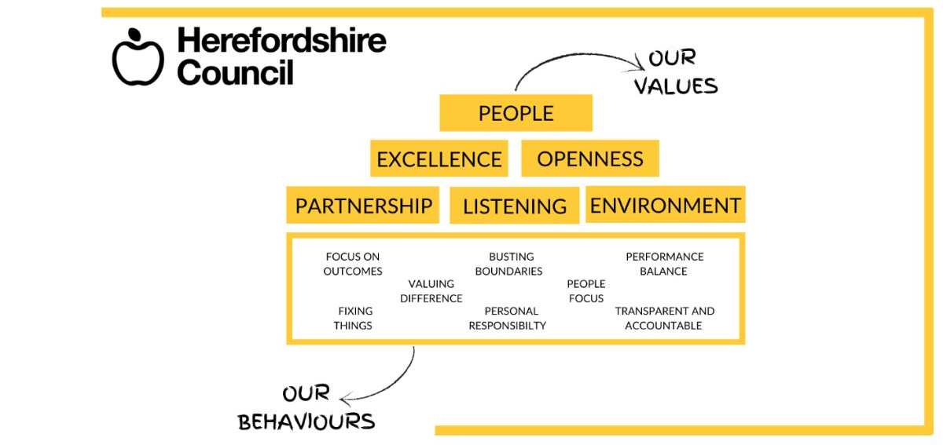
Our values are what we represent as a council, and our behaviours are how we act to get things
done to reach our potential.

