Role Structure | Role Details
Directorate: | Children & Young People
Grade: | HC08
Location: | Plough Lane, Hereford
Responsible to: | Team Manager

Job Description

Social Worker
Assessment

Main purpose of the role

To provide a high quality service in relation to all aspects of assessment work with children, young people and families. Assessment teams complete holistic child-centred assessments, incorporating the child’s identity, ethnicity, gender and culture. This is done by triangulation of information gained from: visiting and speaking with the child to build meaningful relationship throughout the process, consulting with parents/carers, including non-resident parents, step-parents, family members and other professionals who know the child well to inform an outcome focused SMART plan or next steps.

Herefordshire Council aims to work alongside families, to respect families and their rights, to work with them in partnership and with their informed consent, to recognise their strengths and help them identify their needs. Our overarching duty is to promote the upbringing of children within their families, where this is compatible with the welfare of the children.

Social Workers in Herefordshire will be supported to develop high levels of skill in restorative practice which they will use to help parents identify the aspects of their lives/ behaviours that they want to change and provide the help and support to families, on a partnership basis, that they need to support them in their change.

Roles at this level provide professional social work and other support to individuals, children, families and carers living in Herefordshire in line with the requirements of current, relevant, national legislation and local policies and procedures. They engage with individuals, children, families, groups and communities to assess and intervene and using professional judgement employ a range of interventions promoting choice, control and independence.

Key Duties and Responsibilities | Frequency of Task
- To provide an assessment of the needs of family members, their strengths and any risks to children’s health/development or significant harm to the child/ren and develop SMART plans that will meet the needs of family members and reduce risks to children, in conjunction with children and their families | - Daily
- To work with partners to meet those needs and support progress via child in need and core group meetings involving families, young people and relevant professionals. | - Daily
- To conduct child protection investigations where a multi-agency strategy discussion considers there are grounds to believe the child has or is likely to suffer significant harm and to involve families in developing plans for change which will reduce the risk of significant harm and keep children in their families wherever possible. | - Daily
- Where children cannot be adequately cared for within their families or their families cannot be engaged to access services that would support them to change and the significant harm threshold is reached, to initiate discussions to seek agreement for s20 or initiate planned or emergency legal proceedings to ensure children are protected in line with departmental policy, procedures and relevant legislation. | - Daily
- To work with colleagues in commissioning, fostering and adoption to identify high quality placements for children that will promote keeping children with their siblings and engage in timely care planning so children are placed in stable long-term homes where their health and development as well as education and training needs are supported and they can strengthen their resilience to lead a happy and stable adult life | - Daily
- Ensure that social work case records, assessments, plans and documentation for all children and young people for whom you are responsible are effectively maintained in line with practice standards and organisational policy and procedure. | - Daily
- Promote purposeful social work practice and undertake regular supervision that is reflective and outlines clearly the next steps to improve outcomes for children, young people and families. | - Daily
- Manage effective communication of practice, service and organisational issues within the team and work collaboratively across other social work teams, services and with partners to provide high-level integrated support to children and families | - Daily
- Ensure that in all aspects of work that the views, feelings and wishes of children, young people and their parents /carers are taken seriously and used to appropriately inform your assessment and decision making. | - Daily
- Ensure that quality assurance activities are followed and to take an active role in promoting the voice of children, young people, their parents and carers. | - Daily

Person Specification

Requirements | Essential or Desirable | Identified by  A – Application I – Interview
Qualifications and Training
- Social Work Degree, DipSW, CQSW, CSS or equivalent qualification. | Essential | A
- SWE registration | Essential | A
- Committed to continuing professional development | Essential | A, I
Experience & Knowledge
- Up to date working knowledge of relevant national and local policy and statutory guidance and legislation in relation to the provision of social care services | Essential | A, I
- Comprehensive understanding of the roles of different agencies and how they work together. | Essential | A, I
- Knowledge of, and ability to operate within, professional and ethical guidelines. | Essential | A, I
- An understanding of the principles of confidentiality and information governance and how these apply to social care. | Essential | A, I
- Understanding of the principle theories of child development of young people, including attachment theory and the concept of resilience. | Essential | A, I
- An understanding of inclusion, diversity culture, equality, equity and how it impacts practice. | Essential | A, I
- Substantial experience in assessing the needs of, and undertaking direct work with children and young people, with a track record of improving children and young people's lives in a UK setting. | Essential | A, I
- Able to demonstrate understanding of the needs of children/young people in their specialist area. | Essential | A, I
Skills and Abilities
- Ability to communicate appropriately and in a timely way with individuals, carers families, other professionals and team members which is clear, fluent, concise and jargon free and in a courteous calm and professional manner. This includes both verbal and written communication. | Essential | A, I
- Ability to use IT systems effectively, ensure regulatory standards are met and performance standards maintained. | Essential | A, I
- Ability to co-operate and work well with others, support colleagues both within and outside of the team and contribute to the successful achievement of team goals, sharing information and learning whilst supporting others. | Essential | A, I
- Ability to plan, organise and prioritise a demanding workload. | Essential | A, I
- Ability to relate well to children and families, to respect their rights and gain their informed consent. | Essential | A, I
- Ability to communicate effectively in complex or challenging situations. | Essential | A, I

All council staff have a duty to promote the welfare of children, young people, and adults with care and support needs at risk of abuse and neglect who cannot take steps to protect themselves. Ensuring you attend mandated safeguarding children and safeguarding adults training to enable you to recognise the concerning behavior, know how to talk about it, and consent/duty to share information effectively. You will also learn about the legalities and procedures the social care staff can take.

Our Values and Behaviours

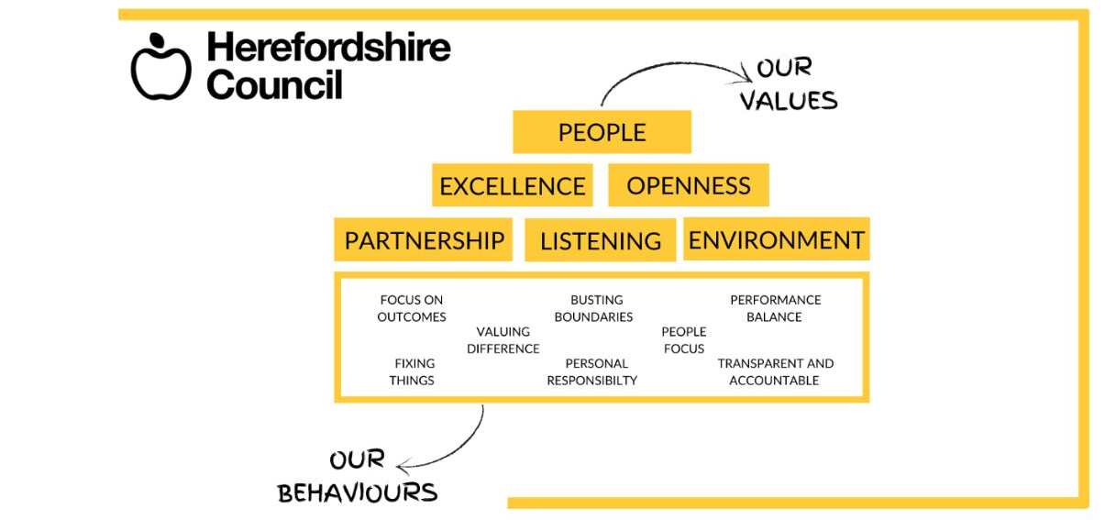
Our values are what we represent as a council and our behaviours are how we act to get things
done to reach our potential.

