Role Structure
Directorate: | Children & Young People
Grade/ Hours | Soulbury point 14 – 16 Term time only (0.86 whole time equivalent)
Location: | School Improvement Service
Responsible to: | Head of Learning & Achievement

Job Description

Secondary School Improvement Advisor -

Learning & Achievement

Main purpose of the role
To work with the Head of Learning and Achievement (and Directorate Team) on all matters related to the performance and strategic management of education within Herefordshire. In particular:
- Providing strategic direction to strengthen and support the governance of schools in the county.
- Providing challenge to all schools to support the development of a self-improving school system in the county.
- Ensuring that statutory responsibilities concerning the performance of all schools/settings in Herefordshire (including academies) are met.
- Working alongside heads of service in the Children and Families Directorate, to monitor, support and provide challenge to all local authority (LA) maintained schools where a need is identified.
- Providing a traded service for school improvement within the county.
- Ensure effective oversight and quality assurance of standards in alternative provision and specialist settings.
- Ensure all children and young people are in receipt of a full-time education under section 19 of the Education Act including those with medical needs, those who have been permanently excluded and those without a school place.
Key Duties and Responsibilities | Frequency of Task
- The provision of high-quality professional advice to schools, colleges, governing bodies and the LA. | - Weekly
- Ensuring that the statutory responsibilities of the local authority in so far as they fall under the remit of the Learning and Achievement Service are met, whether in LA maintained, or in other educational provision. | - Monthly
- Providing advice and support to governors, head teachers, leaders, and LA Senior staff within the outlined areas of responsibility. | - Quarterly
- Ensuring that the work of the team is central to the delivery of the Corporate Plan, Strategies (Education, SEND, Alternative Provision, and Attendance) and Service Area Team/Business Plans. | - Weekly
- Ensuring statutory school improvement requirements are met with regards to schools, including implementing the agreed policy and practice for monitoring, challenge, support and intervention where a school is causing concern | - Weekly
- Managing the agreed policy and practice for the identification of, and intervention in, underperforming schools and colleges. | - Monthly
- Advising the Directorate Team on the appropriate intervention/s when a school is identified by the local authority or Ofsted and managing aspects of that intervention. | - As appropriate
- Where appropriate acting as a School Improvement Adviser to schools and deploying any resources contracted or employed by the council. | - As appropriate
- Assisting with and ensuring the key priorities within the SEND action plan are delivered including assisting with the facilitation of the SENCo network | - Monthly
- Liaising with external bodies e.g. DfE and Ofsted when required. | - As appropriate
- Working with other senior advisers and directorate colleagues to evaluate the impact of the LA school improvement and pupil intervention strategies. | - Monthly
- Developing and completing traded service work as commissioned, working closely with the school effectiveness team who provide support for this function. | - Quarterly
- Attending Ofsted inspection and monitoring visit feedback to schools as required. | - As appropriate
- Write notes of visit using the agreed template and ensure that these are shared with all relevant stakeholders in a timely manner after the visit. | - Monthly
- Contributing to training of school and LA colleagues as required. | - As appropriate
- Maintaining and expanding professional qualifications as opportunities arise. | - Annually
- Assist with the management and support of LA’s statutory and strategic functions around school governance. | - Monthly
- Ensure best practice in school governance is identified and shared, working closely with the school governance officer. | - Quarterly
- To have a good knowledge and understanding of the wider issues affecting school performance. | - Weekly
- Attend and contribute to relevant local authority briefings, meetings and training events and deputise for the Head of Learning and Achievement as required. | - Weekly
- Represent the local authority during headteacher selection processes taking place in the schools, as required, and ensure those appointed receive effective induction and ongoing professional advice. | - As appropriate
- Champion high expectations and inclusive practices, including best practice, so that vulnerable, disadvantaged, and underperforming groups of pupils, including the most able, are supported to achieve their potential | - Daily
- Assist the Head of Learning and Achievement to maintain the Local Authority Directory for Alternative Provision (AP), contribute to the AP steering group and ensure AP commissioned by the Local Authority is quality assured. | - Monthly

Person Specification

Requirements | Essential or Desirable | Identified by  A – Application I – Interview
Qualifications and Training
- Qualified Teacher Status | Essential | A
- Level 5 Diploma or equivalent, higher degree, and specialist/advanced level professional qualifications | Desirable | A
- Ofsted trained and accredited | Desirable | A
- Significant Secondary School Leadership and SEND experience | Essential | A, I
Experience & Knowledge
- Experience of delivering and coordinating secondary school improvement activities either with a school or local authority in a senior leadership role. | Essential | A, I
- Demonstrate success in establishing a performance culture, including improvement planning, target setting and performance management which leads to improved outcomes for pupils | Essential | A, I
- Demonstrate success as an educational leader, with experience of working through influence and partnership with external partners to achieve common goal | Essential | A, I
- Demonstrate understanding, experience and proven impact on SEND and pupil premium | Essential | A, I
- Demonstrate success as a school adviser - NLE | Desirable | A,I
Skills and Abilities
- Ability to operate successfully within a complex and swift moving multi-agency environment. | Essential | A, I
- Evidence of good oral, written and presentation skills to enable the postholder to communicate effectively with a range of staff, managers and other stakeholders at all levels | Essential | A, I
- Ability to lead and develop the professional development of the leaders in schools through the use of coaching, providing clear strategic direction for schools | Essential | A, I
- Ability to design and deliver training materials and resources across Herefordshire | Essential | A, I
- Ability to constructively challenge and provide support to team members and other professionals | Essential | A, I
- Ability to develop and deliver effective school improvement plans | Essential | A,I
- Outcome orientated, with an ability to analyse and process complex data and information quickly and rigorously to be able to evaluate impact of school interventions and support | Essential | A, I

All council staff have a duty to promote the welfare of children, young people, and adults with care and support needs at risk of abuse and neglect who cannot take steps to protect themselves. Ensuring you attend mandated safeguarding children and safeguarding adults training to enable you to recognise the concerning behavior, know how to talk about it, and consent/duty to share information effectively. You will also learn about the legalities and procedures the social care staff can take.

Our Values and Behaviours
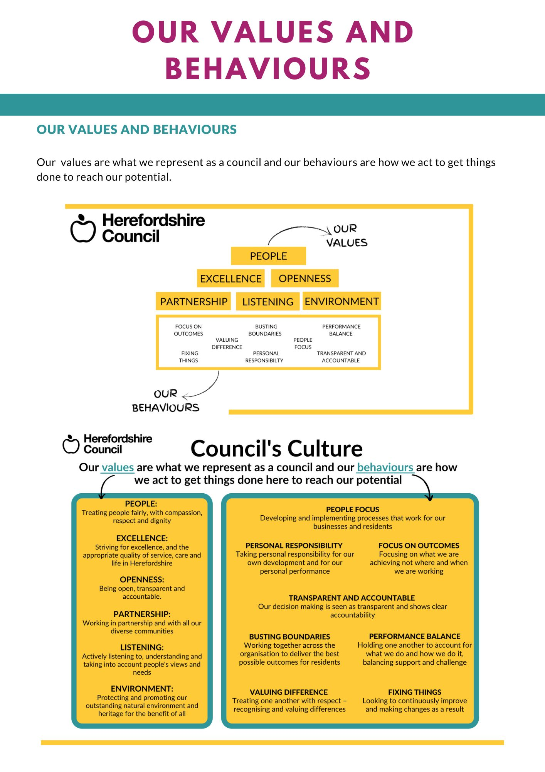
Our values are what we represent as a council and our behaviours are how we act to get things
done to reach our potential.

