Requirements | Role Details
Directorate: | Community Wellbeing
Grade: | HC07
Location: | Whitecross Road Hub
Responsible to: | Rough Sleeper Support Worker

Job Description

Job Role: Rough Sleeper Support Worker
Service: Whitecross Road Hub

Main purpose of the role

Working within the newly established White Cross Hub Team, the RSSW will support rough sleepers and those at risk with the most challenging and complex needs,

The RSSW will be a single, consistent and trusted point of contact for the people they are supporting, enabling them to engage, or re-engage with services from which they would otherwise be excluded and working with them to enable a successful move from the streets into the White Cross Hub (WXH), and ensuring through established trust for both parties that there are open lines of communication enabling the individuals to engage confidently and helping them to sustain their accommodation.

On a day-to-day basis the RSSW will be linking with partner agencies that have a role to play in supporting client interventions and recovery so that they are better equipped to maintain accommodation and independence and avoid returning to the streets. In addition to physical and mental health and wellbeing, this will include client opportunities to engage in leisure activities, volunteering, education, training and employment and to develop positive social networks.

Intensive daily support to clients to promote successful tenancy sustainment will be maintained once the client is housed at WXH but it is expected that positive relationships with those who are currently rough sleeping or accommodated as part of the Project Brave cohort will be established to promote a smooth transition from street sleeping to tenancy responsibilities at WXH.

Key Duties and Responsibilities

- To manage a small caseload of rough sleepers and ex-rough sleepers who have the most challenging and complex needs. The RSSW will provide bespoke packages of support for clients who are experiencing multiple and complex barriers to accessing health, housing, social care and related services.
- Work closely with Citizen Housing and liaise as appropriate in relation to the occupation of the flats/apartments at WXH.

- As part of the established, co-working arrangements with Citizen Housing for the WXH it will be necessary to reinforce ‘house rules’ and to work with clients who may have placed their occupation of WXH in jeopardy due to their behaviors on site, rent arrears or the behaviors of those visiting the premises (as permitted by lockdown restrictions).

- To follow the relevant procedures for ensuring that information and data is collected and recorded accurately so that DLUHC monthly monitoring reports and internal reporting requirements can be confidently completed accurately and produced at due dates.

- To work within a client centered approach through the use of problem solving, innovation and collaborative working with a range of partner agencies. The RSSW will co-ordinate client support services, work with stakeholders and respond to any obstacles that are presented to the client in a solution-focused way.

- To develop solutions and interventions working with a wide range of partner organisations including businesses, the charitable, and voluntary and faith-based sectors, community groups and other statutory agencies. Solutions will be designed to ensure rough sleeping issues are understood more widely with the aim of preventing and reducing the number of people who become roofless in Herefordshire.

- To actively contribute towards the goal of reducing rough sleeping within Herefordshire.

- Demonstrate outcomes for clients in the following areas and evidencing their achievement, through supporting clients to:

- Access and sustain appropriate accommodation.
- Improve their health and wellbeing.
- Support clients to engage in and sustain support and advice for clients who have substance misuse issues.
- Encourage and support clients to engage in opportunities for employment, volunteering, education and training, leisure activity, developing life skills and building positive social networks.

- Complete a full strength-based needs assessment and support plan with each client using a client centered approach and enact support actions/interventions, which will assist clients to achieve their goals and move towards a sustainable life away from the streets. Built in to the support plan will be a client’s PHP as determined by the Homelessness Reduction Act 2017. This will give clients the opportunity to work with the Navigator and actively engage in ending their period of rough sleeping.
- Encourage each client to work through Groundswell’s ‘Escape Plan Notebook to support their own personal journey out of homelessness.

- Record the results of contact with all clients on a daily basis and amend and update the needs assessment and support plan. This will include recording clients’ progress towards achieving identified outcomes and setting new outcome targets. All information relating to clients must be recorded on Herefordshire Councils ABRITAS system.

- Establish daily (as appropriate) support visits to clients once they have moved to WXH, and continue to record the results of contact, as job activity above.

- Assist with monthly HMCLG DELTA monitoring reports and internal monitoring reports for the Service Manager.

- Develop strong links and working relationships with all external partner agencies that have a role to play in supporting client interventions and recovery and liaise frequently. In particular this will include housing providers, probation and prison services, police, drug and alcohol Services, mental health outreach, public health providers, DWP, money advice services, food banks and other charitable, voluntary and faith based organisations operating in Herefordshire.

- Develop strong links and working relationships with all council colleagues who have a role to play in supporting client interventions and recovery and liaise frequently. In particular this will include other colleagues in the Outreach, Housing Solutions and Home Point teams, adult social care, drug and alcohol service commissioners, supported housing commissioners and public health.

- Support clients to engage with their recovery, develop life and social skills, claim benefits address current and historic debts and ASB incidents with previous local housing providers and to build a positive environment for the client to grow, address historic traumas, which may have been the cause/reason for rooflessness, and support clients as necessary to avoid a return to street living.

- Encourage service users to establish social networks and undertake meaningful activities to assist them to develop positive coping mechanisms and promote social inclusion.

- Adhere to council procedures around the management of risk presented to self, colleagues and service users and adhere to lone working procedures.

- Promote and facilitate effective multi-agency and joint working to address begging, street drinking and other street-based activity and to actively encourage the client, with support to address their individual behaviors which resulted in involvement with local law enforcement. As this is a complicated agenda there may/will be the need to work closely particularly with Health Care professionals to provide the necessary support for the personal challenges and goals to be achieved, this can be done by several methods including providing and sourcing, where necessary counselling services for individuals etc.

- Always ensure that all types of communication are handled in accordance with Data Protection Legislation and the requirements of General Data Protection Regulation (GDPR) as required by the councils Data Protection Policy.

- Act at all times as an ambassador for the Herefordshire Housing and homelessness Services and Herefordshire Council, maintaining a professional service standard at all times.

Person Specification

Requirements | Essential or Desirable | Identified by  A – Application I – Interview
Qualifications and Training
- A good standard of general education including a minimum of 5 GCSE’s or a recognised equivalent, a demonstrably good level of numeracy and literacy. | Essential | A
- Excellent IT skills, including competence with word processing, spreadsheets, database and email and ability to learn how to use new IT applications. | Essential | A, I
- A minimum of 2 years’ experience working in a similar background, good working knowledge of homeless legislation and the ability to demonstrate their knowledge | Essential | A, I
Experience & Knowledge
- Experience of working with homeless and/or vulnerable people with complex needs. | Essential | A, I
- Preference will be given to candidates with experience of working with people with mental ill health and/or alcohol/substance misuse support needs and/or an offending history. | Essential | A, I
- Preference will be given to candidates with experience of managing a client caseload. | Essential | A, I
- Preference will be given to candidates with experience of working with clients to develop strength based support plans and to motivate clients to achieve mutually agreed goals and outcomes. | Essential | A, I
- Candidates will be expected to have an understanding of the wider issues impacting upon homelessness and the challenges involved in resolving rough sleeping. | Essential | A, I
- Candidates will be expected to have a working knowledge of how the Acute and NHS Community Mental Health, Drugs and Alcohol treatment services are configured and accessed. | Essential | A, I
- Candidates will be expected to have a knowledge of the benefits system with a view to maximising client income and covering accommodation expense. | Essential | A, I
- Experience of working with individuals who are moving away from Rough Sleeping into any form of accommodation, either settled or temporary. | Essential | A, I
- Candidates will be expected to demonstrate at interview their experience and knowledge of working with clients through the transition into accommodation and how the trauma of rough sleeping can impact upon individuals and the support they require to sustain accommodation. | Essential | A, I
Skills and Abilities
- To be emotionally resilient with the ability to manage behaviour, which can sometimes be challenging, whilst continuing to maintain ongoing constructive engagement with clients. | Essential | A, I
- To be a problem solver, providing a creative solution-focused approach to overcoming challenges. | Essential | A, I
- To have excellent interpersonal skills and the ability to quickly establish relationships and build trust with clients and across a wide range of partners and stakeholders. | Essential | A, I
- To have the ability to assertively coordinate cases involving a number of partner agencies. | Essential | A, I
- To have strong listening skills and the ability to stay calm and patient in challenging situations. | Essential | A, I
- To be strongly motivated to support clients in making a positive difference to their lives. | Essential | A, I
- To have the ability to work sensitively with clients to develop clear support plans that identify mutually agreed outcomes and break these down into achievable goals. | Essential | A, I
- To keep accurate records to contribute to monthly monitoring reports to the DLUHC and to line management, as required. | Essential | A, I
- To have the ability to write reports, incidents and interventions, recording facts accurately without applying personal views unless it is appropriate to do so. | Essential | A, I
- To have the ability to manage financial responsibility in overseeing client personal budgets and financial monitoring. | Essential | A, I
- Have a non-judgemental attitude that is inclusive regardless of an individual’s particular needs or background. | Essential | A, I

All council staff have a duty to promote the welfare of children, young people, and adults with care and support needs at risk of abuse and neglect who cannot take steps to protect themselves. Ensuring you attend mandated safeguarding children and safeguarding adults training to enable you to recognise the concerning behavior, know how to talk about it, and consent/duty to share information effectively. You will also learn about the legalities and procedures the social care staff can take.

Our Values and Behaviours

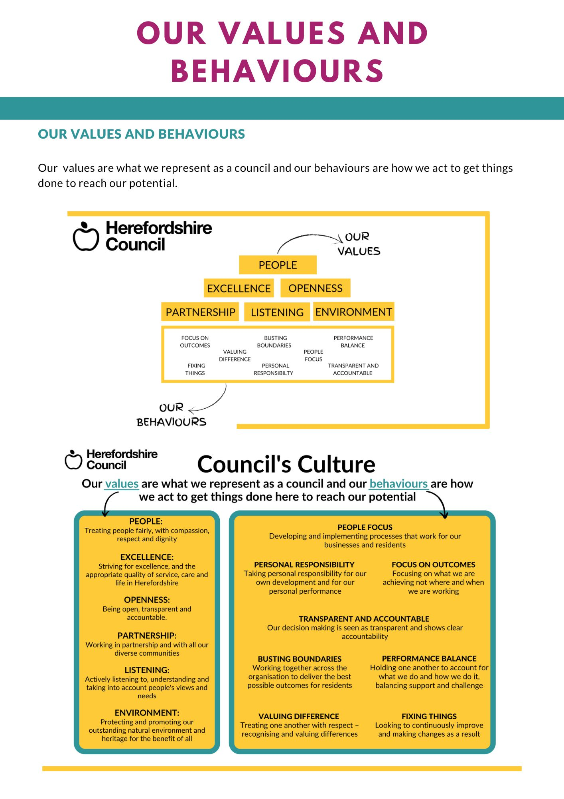
Our values are what we represent as a council and our behaviours are how we act to get things
done to reach our potential.

