Role Structure | Role Details
Directorate: | Economy & Environment
Grade: | HC05
Location: | Herefordshire
Responsible to:

Job Description

Job Role: (Fixed term) Technical Officer
Service: Planning Services

Main purpose of the role

To work as part of the Technical Support Team for Planning Services dealing with the validation and processing of planning and associated applications in line with Town and Country Planning Legislation and audited procedures. Responding to general enquiries in relation to planning matters and providing technical assistance to agents and public in relation to planning applications either, electronically, via telephone e-mail or face to face meetings. Provide assistance to Customer Service Officers and other internal services upon request.

Receive and reconcile planning application fees, and all other associated fees and incomes, internally and externally.

Provide administrative and technical support to the Development Management Team; Agents or consultants; Statutory Bodies and general public.

To process planning documents in line with targets set by the Planning Inspectorate and view redact and upload to the organisations data management system and website.

Key Duties and Responsibilities | Frequency of Task
- Receive, register, validate and acknowledge Applications and ensure payment of the appropriate fee in line with the statutory planning process. Where validation is not possible contact the applicant/agent to explain the scope of the additional information necessary for validation to take place and the consequences of not supplying the information, including the possibility of enforcement action being considered. | - Daily
- Ensure all applications, appeals, representations and associated documentation are scanned and redacted following interrogation for confidential/personal/sensitive information in line with GDPR, Data Protection Act and Information Security Policies before publishing to the website in a timely manner to ensure targets are met. | - Daily
- In relations to all applications and additional services, requesting, receiving & processing fees, ensure monies are banked and reconciled within the prescribed system, and arranging refunds if applicable | - Daily
- To provide timely accurate technical and administrative support within the Development Management Team, which includes meeting strict internal/external deadlines, use of systems updating and redacting records and checking of electronic and hardcopy documentation. | - Daily
- Raise requisitions and invoices for supply of goods and services for Development Management as instructed by the Business Manager; goods receipt items and check administrative correctness before passing for authorisation and payment of invoices. | - Daily
- Provision of efficient, skilled and knowledgeable customer advice for the Development Management service providing technical support and assistance to service users and a wide range of advice and guidance to other staff, service users, councillors and the public on planning matters including technical, administrative and procedural planning issues. . Providing high quality customer care support over the telephone, electronically and in person | - Daily
- To follow the relevant procedures for ensuring that service information and data is collected and recorded accurately using bespoke electronic systems enabling the production of reliable analyses, reports and service information and ensure records are kept in accordance with the Council’s retention schedule, Information Security Policies, Freedom of Information (FOI) and Data Protection Principles. | - Daily
- To act as a Back Office Administrator for the Planning Services Department. To deal with all enquiries sent to the associated planning mailboxes, via service requests and to act as triage between the Customer Services Team and Development Management Team regarding customer management and priority. | - Daily
- Produce all Decision Notice documents, and other statutory letters and other associated Informative Notes allied to any and all planning applications and distribute to Applicants/Agents and Councillors accordingly. | - Daily
- Administration of Planning appeals and including (but not excluded to) hearings and public inquiries. Consulting statutory and non-statutory consultees in accordance with statutory timetables and regulations, organising suitable accommodation, statutory adverts and notices and other technical and administrative support for Development Management Team. | - Daily
- To receive, distribute and process all incoming and outgoing post on a rota basis at Plough Lane Offices. | - Daily
- Take responsibility for the administrative tasks associated with dealing with cases in accordance with service procedures, standards and targets. | - Daily
- Maintain up to date, accurate and timely records of communication, decisions, actions and outcomes relating to cases in line with processes, standards and systems of the Council. | - Daily
- Gather statistics relating to the division of workloads and provide statistical information to Development Managers for Performance Indicators. | - Daily
- Ensure compliance with policies and procedures of the local authority, and those of any partner agencies, and that the service is always delivered in accordance with professional standards, policy and practice and the relevant statutory and regulatory frameworks. | - Daily
- Assist with monitoring and evaluating the effectiveness of the service and contribute to the development of service improvements through participation and involvement in local and central team meetings, supervision, training, conferences and other forums. | - Daily
- To respond by email or telephone to queries/complaints from members of the public with regard to document content. Explain our procedures and correct any errors if necessary. Should a data breach occur, correct and report in accordance with Council Policy. Refer to Business Manager as appropriate. | - Daily
- Maintain ongoing personal training and stay abreast of procedural advice on all aspects of Planning Registration work, to a level necessary to maintain continued function of all duties. | - Daily
- To carry out all the duties required of the post by any appropriate means whether manual, electronic, or other. Including carrying out at a level appropriate to the post, work related to the use and application of new technology. | - Daily
- Work flexibly and respond positively to changing business and client needs and carry out any other duties within the scope of the nature and grade of the post, as directed by the line manager. | - Daily

Person Specification

Requirements | Essential or Desirable | Identified by  A – Application I – Interview
Qualifications and Training
- Minimum of 5 GCSE’s or equivalent including Maths and English | Essential | A, I
- Working knowledge of Windows based computer software | Essential | A, I
Experience & Knowledge
- Hands-on experience of and ability to use IT data and document systems. | Essential | A,
- Experience of working in an office or administration environment | Desirable | A, I
Skills and Abilities
- Ability to work effectively and collaboratively as part of a wider, multi- disciplinary team to deliver to common objectives. | Essential | A, I
- Possess a polite, efficient and helpful manner in dealing with members of the public, applicants & agents and local authority officers in order to provide excellent administration support and customer service | Essential | A, I
- Ability to work both on own initiative and as part of a team, and ability to be adaptable and flexible in working practices | Essential | A, I
- Good attention to detail and accuracy in record keeping | Essential | A, I
- Good time management skills with the ability to prioritise workload and achieve strict deadlines. | Essential | A, I
- The ability to assess situations and make appropriate judgements and decisions | Essential | A, I

All council staff have a duty to promote the welfare of children, young people, and adults with care and support needs at risk of abuse and neglect who cannot take steps to protect themselves. Ensuring you attend mandated safeguarding children and safeguarding adults training to enable you to recognise the concerning behavior, know how to talk about it, and consent/duty to share information effectively. You will also learn about the legalities and procedures the social care staff can take.

Our Values and Behaviours

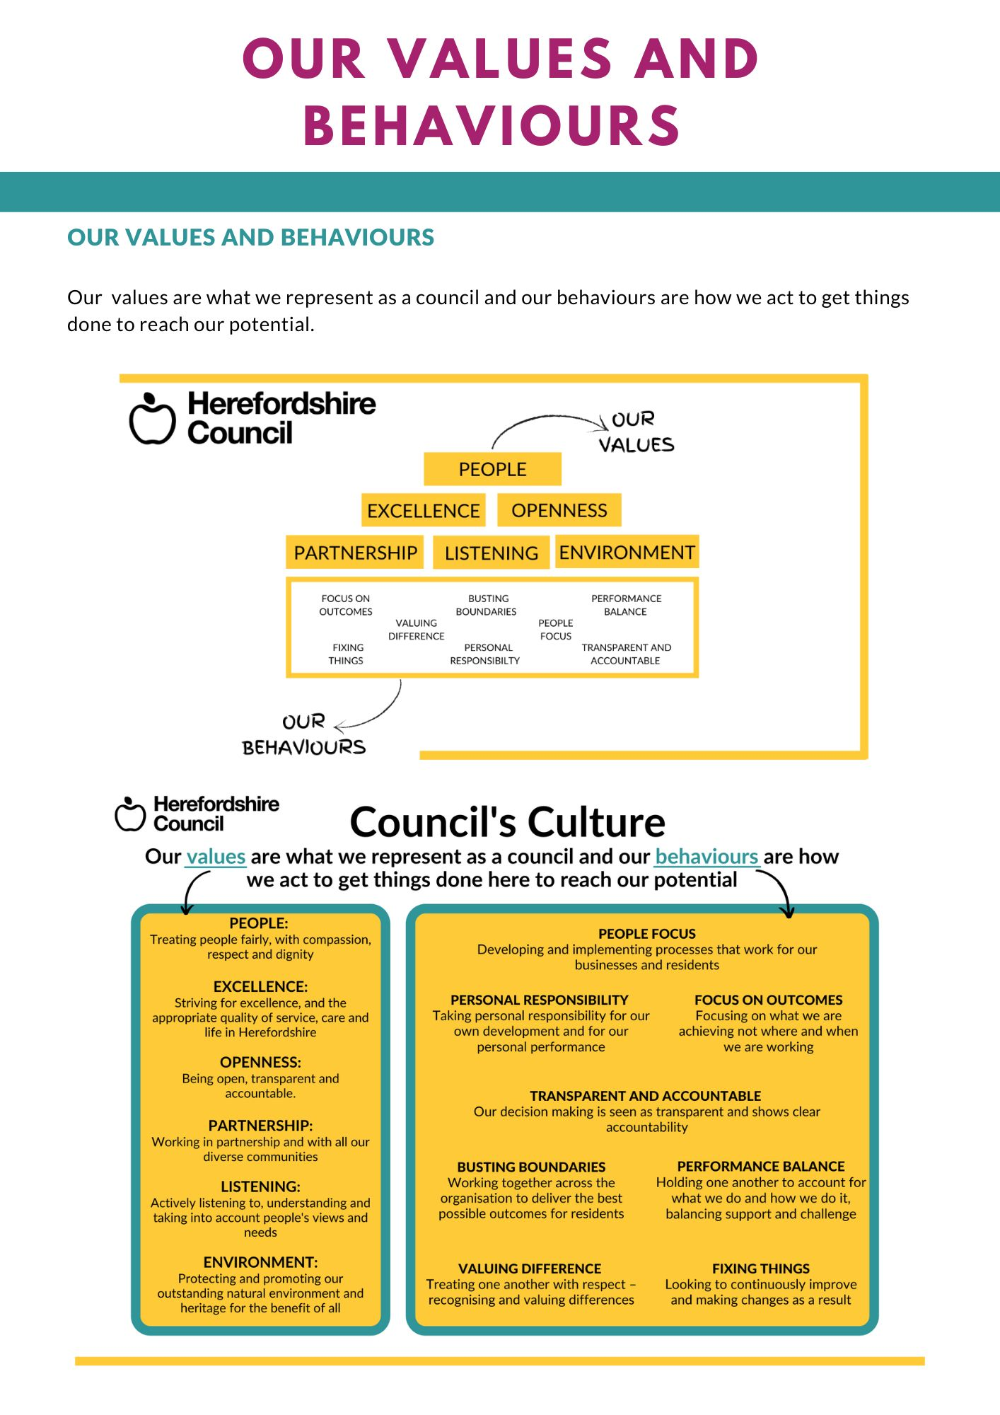
Our values are what we represent as a council and our behaviours are how we act to get things done
to reach our potential.

