Role Structure | Role Details
Directorate: | Children & Young People
Grade: | HC08
Location: | Plough Lane, Hereford
Responsible to: | Team Manager

Job Description

Social Worker
CWD

Main purpose of the role

To work closely with children and their families, other staff within the Directorate and partner agencies to provide
a range of services and support designed to protect children from harm and promote the welfare of children in need.

To work within the legislative framework of the Children Act 1989, and the Children Act 2004

Key Duties and Responsibilities | Frequency of Task
- To carry a caseload in line with the organisational needs of the Directorate | - Daily
- To assess the needs of children, young people, families and carers, take appropriate follow up action in consultation with colleagues, and to plan and implement suitable service provision to safeguard children from harm and meet their identified needs | - Daily
- To undertake preventative and supportive work with children and families in need | - Daily
- To undertake risk assessments | - Daily
- To promote effective planning for children and young people where there are ongoing needs due to:  - Care, Supervision or Adoption Proceedings or Orders  - Entry to the looked after system | - Daily
- To participate in training and development activities to ensure up to date knowledge and skills | - Daily
- To undertake day time office duty on a rota basis | - When required
- To contribute to the development of knowledge and skills of other team members or students as required | - When required
- To ensure effective communication with service users by using and developing skills in direct work with children, young people and their families | - Daily
- To maintain accurate case files | - Daily
- To undertake assessments of need and contribute to effective decision making by producing concise written and verbal reports as required | - Weekly
- To promote effective care planning and good outcomes for children and young people in the looked after system | - Weekly
- To communicate well with foster carers and others in developing a corporate approach to fulfilling responsibilities for looked after children | - Weekly
- To promote active involvement and participation of service users in the planning and provision of services | - Weekly
- To promote the safety and welfare of children who are looked after by enabling them to access independent advocates or the complaints procedure | - Weekly
- To comply with the Directorate’s expectations on monitoring and quality assurance standards with respect to all the above | - Daily

Person Specification

Requirements | Essential or Desirable | Identified by  A – Application I – Interview
Qualifications and Training
- To hold a recognised social work qualification | Essential | A
- Current HCPC registration | Essential | A
- Evidence of continual professional development | Essential | A
Experience & Knowledge
- Knowledge of Children Act 1989 & 2004, and other relevant legislation, regulations and guidance | Essential | A, I
- Knowledge of recent development in social work practice with children and families | Essential | A, I
- Understanding of normal child development and family dynamics | Essential | A, I
- Experience of working in a social care setting | Essential | A, I
- Experience of working with other agencies and of using supervision effectively | Essential | A, I
Skills and Abilities
- To identify and analyse complex family dynamics, identify risks and resources needed | Essential | A, I
- To demonstrate good listening skills and skills in observing non-verbal communication and behaviour | Essential | A, I
- To develop effective working relationships with children, families and professionals | Essential | A, I
- To share information, accurately and concisely with service users, carers, colleagues and other agencies | Essential | A, I
- To use a range of social work interventions | Essential | A, I
- To maintain accurate records and follow required administration procedures | Essential | A, I
- To produce good quality written reports for internal and external purposes, including Court reports | Essential | A, I
- To work effectively as part of a team | Essential | A, I
- To work effectively to national timescales and other operational deadlines, and to plan, prioritise and evaluate own work | Essential | A, I
- To work flexibly, act on own initiative where appropriate and accept delegated responsibility | Essential | A, I
- To hold a non-judgmental attitude towards attitude towards people | Essential | A, I
Other Factors
- Understanding of the need for supervision and to accept constructive criticism | Essential | A, I
- Understanding of the Social Care role within Local Government and the role of other agencies and professionals | Essential | A, I
- Understanding the needs of service users from a wide range of backgrounds | Essential | A, I
- Understanding and demonstration of commitment to Equal Opportunities principle | Essential | A, I
- Ability to travel freely in and out of the County | Essential | A, I

All council staff have a duty to promote the welfare of children, young people, and adults with care and support needs at risk of abuse and neglect who cannot take steps to protect themselves. Ensuring you attend mandated safeguarding children and safeguarding adults training to enable you to recognise the concerning behavior, know how to talk about it, and consent/duty to share information effectively. You will also learn about the legalities and procedures the social care staff can take.

Our Values and Behaviours

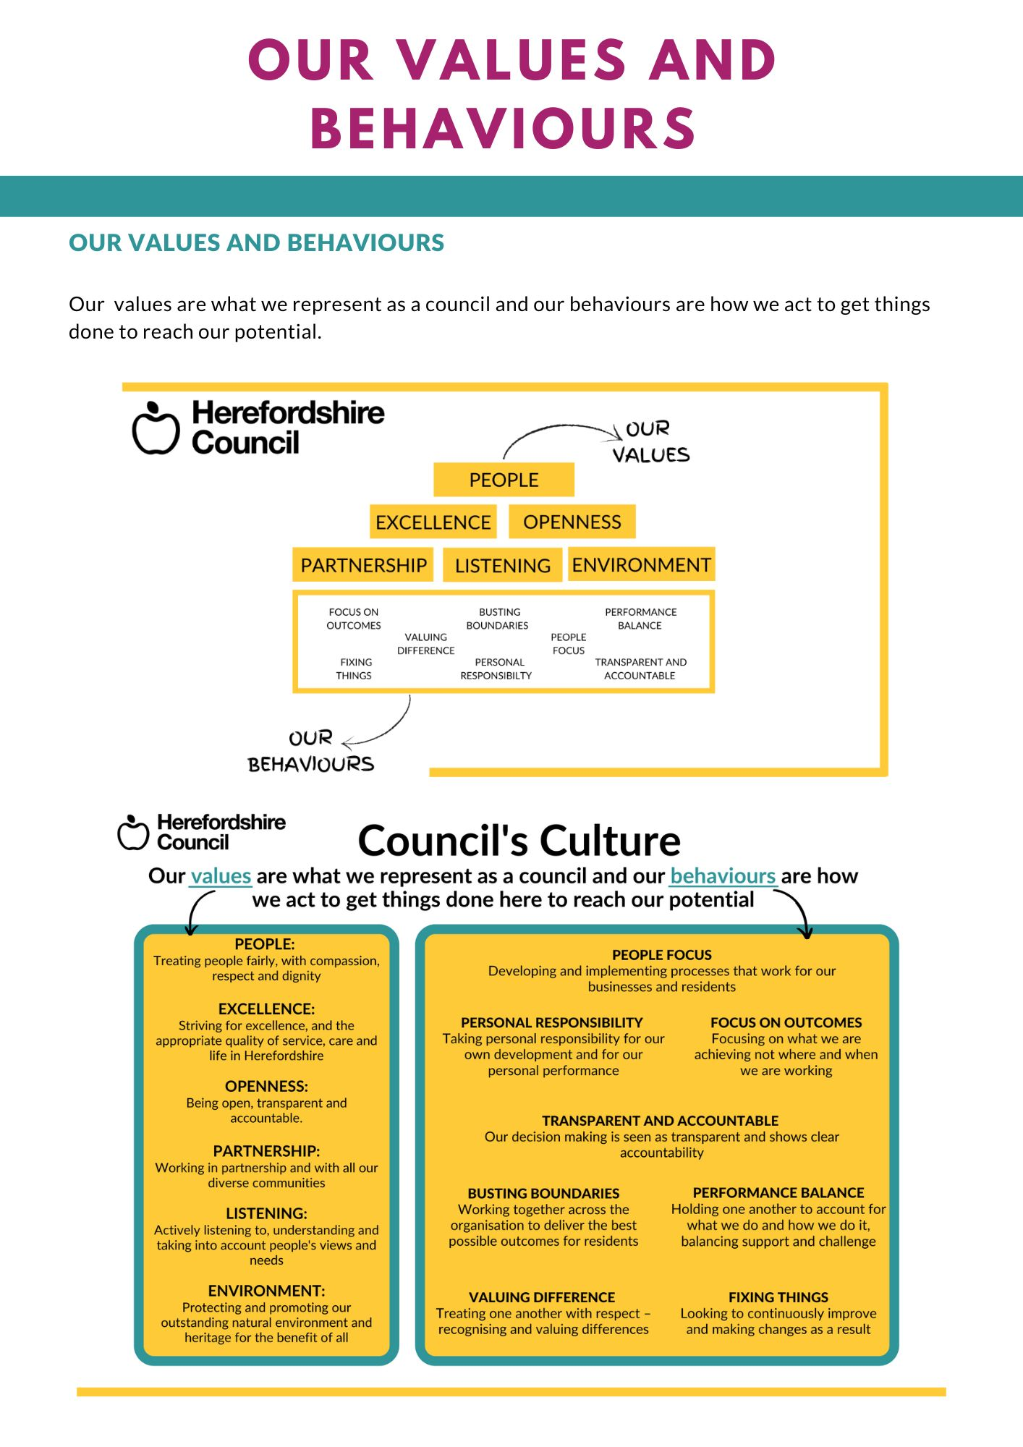
Our values are what we represent as a council and our behaviours are how we act to get things
done to reach our potential.

