Role Structure | Role Details
Directorate: | Children & Young People
Grade: | HC6 SCP11
Location: | Hereford
Responsible to: | School Effectiveness Team Manager

Job Description

Governor Support Co-Ordinator

Main purpose of the role

To provide advice and guidance to the Governing Board on Governance, Constitutional and Procedural matters. A professional governor support co-ordinator will contribute towards the efficient functioning of a governing board and its committees by providing:

- Administrative and organisational support
- Guidance to ensure that the board works in compliance with the appropriate legal and regulatory
framework, understands the potential consequences for non-compliance and able to give advice on
procedural matters relating to the operation of the board.
- To establish and maintain good working relationships between all staff and partners.
- To follow the relevant procedures for ensuring that information and data is collected and recorded
accurately thus enabling the production of reliable analysis and reports.

All staff are:

- Expected to make significant contributions to the development and/or implementation of the
Herefordshire Children and Young People’s Plan in their area of service delivery.
- Accountable for their work and should ensure that work output and quality is of the highest quality and
in accordance, where appropriate, with current regulations/legislation/Council standards.
- Responsible for their own continuous self-development in order to enhance their own performance
and expected to undertake relevant training and development.
- Expected to promote the Council’s employment policies, with particular reference to diversity,
equality of access and treatment in employment and service delivery and to support /develop a
working culture within these services that reflect the Council’s vision.
- Information and data quality: Working within resources provided to ensure local systems, skills and
processes are in place and applied consistently to secure high quality information, data, analyses and
reports.

Key Duties and Responsibilities | Frequency of Task
- To be able to advise the board on its core functions and keep them up to date with the latest Department for Education governance advice – the Academy Trust Governance Guide or Maintained School Governance Guide. These can be found here  - Be able to advise the Governing Board on governance legislation and procedural matters where necessary before, during and after meetings  - Inform the governing board of any changes to its responsibilities as a result of a change in school status or changes in the relevant legislation  - Offer advice on best practice in governance, including on committee structures  - Ensure all statutory policies are in place, and remind Head Teacher of policy retention schedule when necessary  - Advise on the annual calendar of governing board meetings and tasks  - Send new governors an induction pack and ensure they have access to appropriate documents, including any agreed Code of Conduct in liaison with the Head Teacher  - Contribute to the induction of governors taking on new roles, in particular chair of the board or chair of a committee  - Identifies priorities, anticipates issues which may arise and draws these matters to the chair’s attention and propose recommendations  - Clerk any statutory appeal committees/panels the governing board is required to convene: if the clerk is not contracted to set up and clerk these panels, the governing board will have to make an alternative arrangement  - Establish, in discussion with the board, open and transparent vacancy filling processes and procedures for election and appointment so elections or appointments can be organised in a timely manner  - To support the wider management of the School Effectiveness Team with regard to meetings and the Service Plan  - To work with the Chair of Governors and the Headteacher on the contents of the agenda and the supporting papers for each meeting of the governing body. This work shall be undertaken at least two weeks before the meeting.  - To check with the Chair on any actions that have been taken by him/her between meetings and that they are reported to the governing body  - To prepare and send out the papers to the governing body providing at least seven clear days’ notice.  - To attend governors’ meetings, ensure they are quorate and take accurate notes from which to prepare the minutes.  - To write, produce and send copies of the draft minutes to the Chair for approval. (Some governing bodies may require the Head to receive a copy).  - To check on the dates of expiry of terms of office and provide information to the governing body as necessary.  - To inform the Chair and the LA of any resignations and appointments and ensure that action is taken to fill a vacancy.  - To deal with correspondence on the appointments of co-opted governors.  - To maintain relevant files and records of correspondence and documents.  - Chair the part of the meeting at which the chair is elected, giving procedural advice concerning conduct of this and other elections  - Collate and maintain information about Governors such as any pecuniary interests  - Ensure Disclosure and Barring (DBS) has been carried out on any governor when it is appropriate to do so  - Maintain a record of training undertaken by members of the governing board  - Maintain governor meetings attendance records and advise the Chair of potential disqualification through lack of attendance  - Advise the governing board on succession planning (of all roles, not just the Chair)  - Know where to access appropriate legal advice, support and guidance, and where necessary seek advice and guidance from third parties on behalf of the governing board  - Maintain up to date records of the names, addresses and category of governing board members and their term of office and inform the governing board and any relevant authorities of any changes to its membership  - Maintain copies of current terms of reference and membership of any committees and working parties and any nominated governors  - Maintain a record of signed minutes of meetings in school, and ensure copies are sent to relevant bodies on request and are published as agreed at meetings  - Ensure copies of statutory policies and other school documents approved by the governing board are kept in the school and published as agreed on the Schools website  - Develop and maintain effective professional working relationships with the chair, the board and executive leaders  - Contributes to the coordination of effective learning and development opportunities for those involved in governance, including induction and continuing professional development  - Undertake appropriate and regular training to maintain his/her knowledge and improve practice  - Keep up-to-date with current educational developments and legislation affecting school governance  - Participate in regular performance management  - Maintain a file of relevant DfE, Local Authority, Diocesan guidance documents  - Prepare briefing papers for the governing board, as necessary  - Assist the chair of Governors with the coordination of skills audits as appropriate. | - As required

Person Specification

Requirements | Essential or Desirable | Identified by  A – Application I – Interview
Qualifications and Training
Minimum of 5 GCSE’s, grades A-C, or equivalent, including English Language, or ability to demonstrate attainment at NVQ Level 2, or previous experience of administrative work. | Essential | A, I
Ability to use computer software within the windows package e.g. Access, Word, Excel, Outlook, Teams etc. | Essential | I
Understanding of database systems | Essential | I
Evidence of CPD in a wide range of relevant areas | Desirable | A, I
Experience & Knowledge
Experience of working in an education setting would be advantageous | Essential | A, I
Planning, co-ordinating and prioritising work objectives to deliver work on time and within agreed parameters | Essential | A, I
Experience of providing support as an Executive or Personal Assistant would be advantageous | Essential | A, I
Working effectively as an individual and as part of a team with minimal supervision | Essential | A, I
Ability to work on own initiative, to be able to demonstrate planning and organisational skills so as to ensure service delivery is maintained | Essential | A, I
Organising and recording minutes and actions | Essential | A, I
A proven ability to analyse, assimilate, interpret and apply complex information, particularly legislation, procedures and statutory guidance from a wide range of sources. | Essential | A, I
Ability to use computer software within the windows package e.g. Access, Word, Excel, Outlook, Teams etc – to include the development, operation and maintenance of databases | Essential | A, I
Skills and Abilities
Excellent written and verbal skills, which demonstrate an ability to communicate and present information effectively. | Essential | A, I
Ability to work under pressure and prioritise tasks effectively. | Essential | A, I
Ability to plan and organise effective systems and to inform the implementation of these | Essential | A, I
Knowledge of the way in which schools and academies operate. | Essential | I
Excellent communication, diplomacy and interpersonal skills | Essential | A, I
Ability to work effectively with staff at all levels. | Essential | A, I
Clear understanding of the importance of confidentiality and the discreet handling of sensitive information. | Essential | A, I
Ability to produce high quality accurate work to tight deadlines. In line with agreed requirements. | Essential | A, I
Self-motivated and ability to work with minimal supervision, managing a complex and varied workload with high demand. | Essential | A, I
Ability to work alone outside normal hours without management support | Essential | A, I
Ability to respond to the changing work patterns that the post requires | Essential | A, I
Committed to delivering high quality services and striving for continuous improvement | Essential | A, I
Able to demonstrate ownership with regard to all aspects of work. | Essential | A, I
Willingness to continuously improve working practice to improve performance, incorporating new technology. | Essential | A, I
The ability to keep effective records. | Essential | A, I
A willingness to enhance personal performance by seeking out constructive feedback, gaining insight and awareness of personnel strengths and challenges. | Essential | A, I
Other Factors
Flexible approach to work and hours outside of normal hours to satisfy the needs of the business | Essential | I
The willingness, where necessary or as directed, to work flexibly, including evenings. | Essential | I
A flexible approach to arrangements in order to meet the needs of the service and the workload of the team. | Essential | I
Ability to use ICT packages for a variety of purposes, including use of word processing, databases, e-mail and presentation software | Essential | I
Ability to work from home | Essential | I
Commitment to fairness and equality | Essential | I

Other information:
Disclosure type: DBS

This is a Politically Restricted job, i.e. the jobholder cannot;
- be a candidate, or prospective candidate for election as an MP, MEP or local authority councillor
- act as an election agent or sub agent for a candidate for election as an MP, MEP or local authority councillor
- hold office in a political party
- canvass at elections on behalf of a political party
- speak or write in public in a manner that appears to be designed to affect public support for a political party.

The post holder is occasionally required to work evenings or attend events at the weekend.

Safeguarding.
The post holder needs to have safeguarding training at the appropriate level as defined by the current HSCB training framework
All council staff have a duty to promote the welfare of children, young people, and adults with care and support needs at risk of abuse and neglect who cannot take steps to protect themselves. Ensuring you attend mandated safeguarding children and safeguarding adults training to enable you to recognise the concerning behavior, know how to talk about it, and consent/duty to share information effectively. You will also learn about the legalities and procedures the social care staff can take.

Our Values and Behaviours

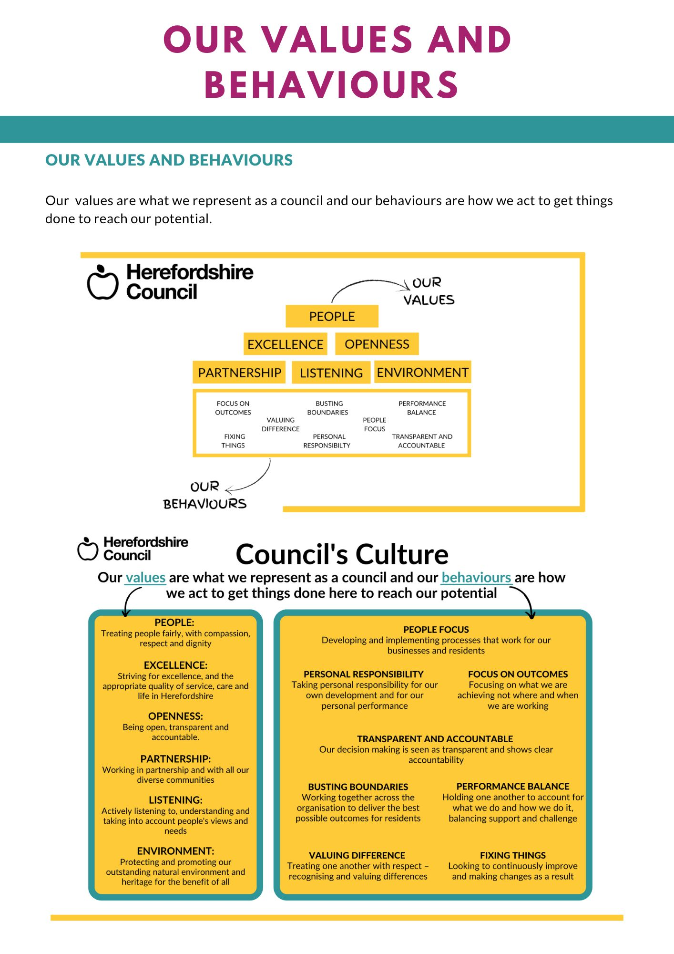
Our values are what we represent as a council and our behaviours are how we act to get things
done to reach our potential.

