Role Structure | Role Details
Directorate: | Children & Young People
Grade: | HC10
Location: | Hereford City to work throughout the county
Responsible to: | Team Manager

Job Description

Systemic Family Therapist
ECHO

Main purpose of the role

The Systemic Family Therapist role is to provide home and community based family therapy sessions with young people and their families. Referrals will be made by social workers and will largely be for families with young people on the edge of care or for families where the plan is for children to be reunified with their birth parents after a period in care. Intensive packages of support will be provided alongside family support workers in the team. The Systemic Family Therapist will support the team in developing systemic conceptualisations and broader ways of understanding and working with families. This will be achieved through supervision, formulation, teaching. They will support the ECHO team to develop a therapeutic stance.

Key Duties and Responsibilities | Frequency of Task
- To provide therapeutic interventions, including family work and individual work with children and young people | - As required
- Working within a multi-disciplinary therapy team, to develop the therapeutic provision within the ECHO team, drawing on systemic formulation, skills and practice | - Daily
- To offer training and workshops to other ECHO team members and wider colleagues in the department | - As required
- Support professionals within the community on how to communicate and develop strategies with traumatised children in order to reduce challenging behaviours and help build adult/child attachments | - As required
- Working closely with the community to produce professional, comprehensive , therapeutic multi-disciplinary assessments /recommendations for children and their carers | - As required
- Provide clear and regular update reports and reviews of therapeutic work for internal and external colleagues | - As required
- Support families to prevent children and young people from entering the care system | - As required
- Support families where children are being reunified with their birth parents after a period in care | - As required
- Making effective use of supervision, support, training and guidance | - As required
- Provide therapeutic interventions giving due regard and consideration to issues of racial, religious, cultural and sexual orientation | - As required
- Knowledge of the latest research, theory and literature to support evidence based practice | - As required
- To be part of regular discussions and reviews of children’s care and support internal colleagues and external partner agencies | - As required
- Maintain an up to date knowledge of the latest research and theories alongside relevant legislation and safeguarding policies and procedures | - As required
- Be a qualified Systemic Family Therapist, providing specialist systemic psychotherapy services to children, young people and their families and consultation to the professional network bringing a systemic perspective to all aspects of the work of the ECHO team | - Ongoing
- Work autonomously and as a member of the multidisciplinary team providing generic and specialist systemic psychotherapy assessments, therapy, care planning and interventions | - Ongoing
- Provide specialist advice and consultation on systemic formulations and practice to ECHO colleagues and social workers | - As required
- Identify, analyse and interpret complex clinical facts using well developed interpersonal and communication skills to communicate highly sensitive condition related information and potentially distressing decisions to clients and colleagues in contexts of challenging behaviour and potentially high emotive atmosphere, working in emotionally demanding environments and/or difficult working conditions | - Daily
- Draw upon highly developed theoretical and practice knowledge in Systemic Psychotherapy gained from masters or equivalent entry requirements utilising extensive specialist knowledge from qualifications in more than one discipline | - Daily
- Work autonomously interpreting Herefordshire Council’s policies and procedures in relation to a defined caseload and working within professional guidelines and ensuring continuous professional development | - Daily
- Participate in teaching and service development. Commitment to own ongoing professional development and contribute to service development and the professional development of others | - Daily

Person Specification

Requirements | Essential or Desirable | Identified by  A – Application I – Interview
Qualifications and Training
- Entry level Masters equivalent dual qualifications and experience | Essential | A
- First post-graduate qualification in appropriate mental health/social welfare profession e.g. social worker/nurse/psychologist or AFT agreed equivalent plus | Essential | A
- Masters qualification in Systemic Psychotherapy or AFT accredited equivalent (usually 4 years academic study, assessed clinical training and supervised practice including the full range of models within systemic practice and life span development) | Essential | A
- Eligible for UKCP registration | Essential | A
Experience & Knowledge
- Relevant practice in first profession plus clinical experience | Essential | A, I
- Experience of working with children, young people and their families | Essential | A, I
- Some experience of working with different client groups, including adults who may have experienced mental health difficulties, substance abuse or domestic abuse | Essential | A, I
- Experience of working in a multi-disciplinary team | Essential | A, I
Skills and Abilities
- Ability to challenge poor behaviour | Essential | A, I
- Role modelling good behaviour | Essential | A, I
- A positive attitude and able to act on feedback | Essential | A, I
- Ability to praise and be supportive to others | Essential | A, I
- Ability to communicate clearly and effectively in English in both verbal and written formats | Essential
- Ability to identify and employ mechanisms of clinical governance as appropriate, to support and maintain clinical practice in the face of regular exposure to highly emotive material and challenging behaviour | Essential
- Skills in using complex methods of specialist systemic assessment, intervention and clinical management in a range of contexts frequently requiring sustained and intense concentration and maintaining a restricted position for long periods | Essential
- Ability to exercise autonomous responsibility making clinical judgments in highly complex, challenging and emotive situations interpreting Herefordshire Council’s policies and working within professional guidelines | Essential
- Ability to provide specialist therapeutic packages of care regarding a range of mental health problems | Essential
- Ability to contribute to research, audit, teaching and training | Essential
- Ability to share learning within the ECHO team and the wider department | Essential
- Ability to utilise and apply theory and research | Essential
- Ability to work both independently and within a multidisciplinary team | Essential
- Ability to provide specialist advice and consultation on systemic formulations and practice to colleagues in other disciplines | Essential
- Ability to communicate effectively, orally and in writing, complex, highly technical and/or clinically sensitive information to clients, their families, carers and other professional colleagues both within and outside Herefordshire Council | Essential
- Skills in liaison with other agencies and in providing consultation to other professional and non-professional groups | Essential
- Ability to work in complex situations, to manage risk and deal sensitively with stress | Essential
- Ability to maintain a high degree of professionalism in the face of emotive and distressing problems | Essential
- Ability to maintain high standards of record keeping and report writing, including electronic data entry and recording | Essential
- Skills in presentation and ability to use a variety of multi-media materials | Essential
- Ability to use supervision effectively | Essential
- Ability to identify and employ mechanisms of clinical governance as appropriate, to support and maintain clinical practice in the face of regular exposure to highly emotive material and challenging behaviour | Essential
- Good organisational skills and ability to prioritise and keep high standards of record keeping | Essential
- Commitment to continued professional development | Essential

All council staff have a duty to promote the welfare of children, young people, and adults with care and support needs at risk of abuse and neglect who cannot take steps to protect themselves. Ensuring you attend mandated safeguarding children and safeguarding adults training to enable you to recognise the concerning behavior, know how to talk about it, and consent/duty to share information effectively. You will also learn about the legalities and procedures the social care staff can take.

Our Values and Behaviours

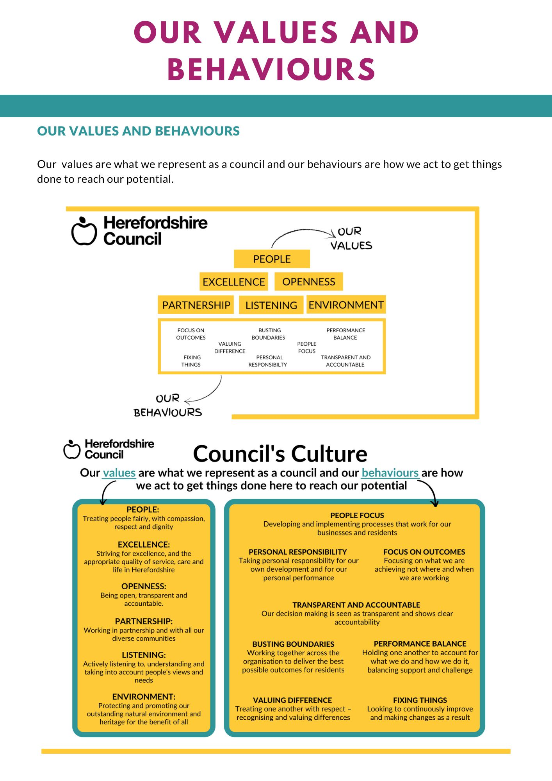
Our values are what we represent as a council and our behaviours are how we act to get things
done to reach our potential.

