Role Structure | Role Details
Directorate: | Children & Young People
Grade: | HC06
Location: | Plough Lane
Responsible to: | Fostering Recruitment and Assessment Team Manager

Job Description

Fostering Training and Recruitment Support Officer
Fostering & Adoption

Main purpose of the role

One of our main priorities is to engage more local foster carers and connected carers, so children in care in Herefordshire can stay within the county, and their family if possible, therefore facing less disruption and unnecessary changes to their lives. It is important that foster carers and connected carers receive comprehensive training and support to enable them to respond to and meet the needs of children in their care.

The main purpose of this role is to support in developing and delivering an extensive programme of training for our foster carers and connected carers, which is varied and in line with current guidance. The Training and Recruitment Support Officer will also assist with recruitment activity for foster carers, primarily processing application forms, ensuring all checks and references are completed.

In this role the Officer will work with carers, the fostering service and other professionals to coordinate and assist with the development and presentation of training for foster carers and connected carers. The Officer will support, encourage and facilitate carers’ engagement in training and ensure training data is captured in line with compliance requirements.

This is a key role within the Herefordshire Council Fostering Service, ensuring foster carers receive the training and develop opportunities they need, and ensuring the recruitment process for new carers goes smoothly. The Officer will need to work directly with carers, those within the fostering service, other professionals and agencies to coordinate and deliver a good training offer to carers. They will need to be able to communicate well with other professionals and agencies to source a range of training opportunities.

The Training and Recruitment Support Officer will be expected to gather the views of carers, the fostering service and other professionals, to inform the training offer, and recruitment activity and process. They will also need to ensure there is evaluation of training and the recruitment and assessment process from carers and others, to ensure a good standard of service delivery.

The Officer will be responsible for collecting and maintaining data to track areas such as mandatory training completion, for compliance purposes. They will also need to support in tracking and providing information to carers and social workers at times to show what training has been completed. They will also need to support with recording data in relation to recruitment activity. The Officer will need to be able to use data to identify patterns in training completion, for example identifying gaps in training offer and best ways of delivering training. They will use this to inform training sufficiency and strategy, informing future priorities for training.

The Training and Recruitment Support Officer will be responsible for supporting in implementing the annual training offer for carers, in accordance with the Council’s development plan. They will report to and liaise closely with the Fostering Recruitment and Assessment Team Manager, in order to develop and monitor the training offer, and recruitment of carers.

They will need to have knowledge and understanding of the needs of children in care, fostering and child care legislation and requirements of the Fostering Service. The Officer will need to have knowledge of and ability to communicate information regarding the Fostering National Minimum Standards 2011 and Herefordshire Council’s fostering policies, to ensure training is in line with this.

Key Duties and Responsibilities | Frequency of Task
- Work closely with foster carers, the Fostering Service and other professionals and agencies to develop and deliver an annual calendar of training to foster carers and connected carers.  - Design and support the delivery of a range training and development activities and opportunities to increase foster carer and connected carer engagement and participation levels in training and service development.  - Be responsible for implementing the training offer. | - Daily
- Work with internal colleagues, partner agencies and external providers to identify a variety of good quality and cost effective training opportunities for carers.  - Identify opportunities to promote new and efficient ways of working, engaging with and securing key stakeholders to provide a comprehensive and value considered training offer.  - Identify and organise suitable and cost effective venues for training.  - Source bespoke or small group training/resources to meet individual needs of carers as requested by fostering team.  - Support in arranging events and projects within the Fostering Service, community and other as appropriate. | - Daily
- Plan, manage and oversee the training portfolio for foster carers and connected carers, ensuring key learning objectives are aligned to national standards. | - Daily
- Maintain the spreadsheet and be responsible for collating data relating to training of carers, to inform strategy and ensure compliance.  - To set up data systems which track sufficiency, attendance and evaluation of training, to be able to inform managers for reporting and auditing purposes.  - Be responsible for analysing this data and presenting to line manager for relevant reports. | - Daily
- Complete records of work undertaken and maintain electronic files in accordance with departmental and service policies, procedures and guidance, documenting details of communication with carers, evaluation following training, recording foster carers training and other relevant information. | - Daily
- Provide pro-active support to carers and those in the Fostering Service in relation to training for foster carers. Providing access to learning resources, advice and guidance. | - Daily
- Be responsible for ensuring there is a comprehensive and varied training offer, to help provide sufficient development opportunities for carers to support them in caring for children.  - Engage with foster carers to promote training and development opportunities and to understand foster carers training needs. | - Daily
- Be responsible for own time management in ensuring training programme is completed, training sessions run efficiently and all data and relevant information is captured. | - Daily
- Maximise the use of a range of training methods, including e-learning to deliver agreed learning outcomes. | - Daily
- There may be a need to complete some tasks outside of normal office hours (for example in the evenings) to suit the needs of the service and carers.  - There will also be times where evening or occasional weekend work is required to support in running training and fostering events. | - As required
- Work closely with the leadership team to oversee a plan to improve service levels in fostering and connected care training, and report on key activities to meet targets. | - Daily
- Establish and maintain strong and productive relationships with key stakeholders ensuring that the service requirements for foster carers are understood, communicated effectively to a variety of audiences, and are incorporated into a framework of best practice.  - Act as a key liaison with carers in relation to training. Ensuring good communication with them regarding training opportunities. Supporting them to engage in training as needed.  - Work closely with carers develop the training offer, include them in training and to encourage them to use their word of mouth to encourage others to participate in training.  - Develop the service and promote the involvement of foster carers and connected carers within their training pathway.  - Form and maintain effective working relationships with carers, colleagues, other professionals and agencies. Liaise with other agencies, local authorities and professional bodies to support in the development of the training offer. | - Daily
- Support with arranging and facilitating training events.  - Promote and raise awareness of training opportunities and needs to carers and the Fostering Service, to ensure carers are aware of training programme, and are able to feed into development of the training offer.  - Develop promotional materials (through newsletters, on website etc.) to share information of training. Ensure information is available through a range of sources, to promote accessibility for carers.  - Ensure a suitable booking system is in place for training events.  - Evaluate the success of training courses and participation in various training, and provide regular reports to the manager to ensure best practice and a flexible response to the needs of the service.  - Keep abreast of fostering trends across the country to enable up to inform training offer, and to link in with other events and organisations.  - To review and revise policies and procedures around the training of foster carers in line with national trends, practice developments and changes in legislation. | - Daily
- To represent the team and service at meetings and events including meetings with partners and stakeholders.  - To demonstrate awareness/understanding of equal opportunities and other people’s learning and development needs.  - Promote and implement the council’s equality policy in all aspects of employment and service delivery.  - To work as part of a team, attend and contribute to team meetings and service development. | - Daily
- Ensure high level of customer experience and content delivery.  - Comply with, confidentiality & data protection issues. | - Daily
- Be committed to personal development and keep up to date with changes in learning and organisational development practice, including the use of technology to support learning. | - As required
- To support with covering some of the tasks of the Fostering Recruitment and Marketing Officer, such as responding to enquiries from prospective carers. | - As required
- Support with collating data on recruitment strategy and marketing evidencing progress of enquiries thought to application and assessment.  - Support with maintaining data systems which evidence progress of enquiries and performance on recruitment to line manager for reporting and auditing purposes.  - Be able to analyse this data and present to line manager for relevant reports. | - As required
- Process application forms for all prospective general foster carers. This includes sending out the requests for all relevant checks and references, keeping a record of those sent and received, and ensuring all checks are completed in a timely manner.  - Complete DBS checks - verify applicants' documents and complete DBS process as required. | - Daily
- Be responsible for seeking and collating feedback from applicants at the end of the recruitment and assessment process. | - Daily

Person Specification

Requirements | Essential or Desirable | Identified by  A – Application I – Interview
Qualifications and Training
- Maths and English to at least GCSE/A Level Standard or equivalent | Essential | A, I
- ICT qualification | Essential | A, I
- Relevant or transferable NVQ in related field. | Essential | A, I
Experience & Knowledge
- Relevant experience of direct training and accompanying evidence of training achievements  - Experience of devising, organising, presenting, and evaluating training materials  - Experience of delivering training courses from various platforms. | Essential | A, I
- Demonstrate an understanding of the safe working practices that apply to this role.  - Ability to work in a way that promotes the safety and well-being of children and young people/vulnerable adults. | Essential | A, I
- Experience in childcare and safeguarding practice and demonstrable knowledge and understanding of the law relating to childcare, fostering and adoption.  - Understanding of fostering legislation and guidance, including basic understanding of the 1989 Children Act, 2010 Care Planning and Placement of Children Regulations, the Fostering Service regulations 2011 and Fostering National Minimum standards. | Essential | A, I
- Knowledge of relevant childcare legislation and Government initiatives  - Good analytical skills  - Knowledge of fostering matters and the issues surrounding children and young people who are cared for by the Local Authority  - Knowledge of resources – health, local authority, voluntary and independent sector, with an understanding of services within the wider organisational system.  - Experience of direct work with foster farers or/and kinship carers. | Desirable | A, I
- Able to communicate and liaise effectively to a range of stakeholders, other agencies, and professionals to effect change.  - Experience of working as part of a team whilst also being able to work individually. | Essential | A, I
- Up to date knowledge and experience of technology. | Essential | A, I
Skills and Abilities
- Excellent and accurate standard of written and verbal communication.  - Able to effectively transfer key and complex information to a wide audience adapting the style of communication as necessary and ensuring that this information is understood. | Essential | A, I
- Excellent recording and report writing skills using electronic data information systems, with the ability to extract and evaluate information. | Essential | A, I
- Computer literate in the use of IT and spreadsheet systems for recording and data collation purposes. | Essential | A, I
- Proven knowledge and skills in using website and database systems. | Essential | A, I
- Excellent organisational skills, with the ability to prioritise tasks and to work to timescales and deadlines whilst managing a varied workload and providing attention to detail. | Essential | A, I
- Able to work with foster carers and the fostering team to facilitate foster carers attendance and engagement in training taking a proactive and problem solving approach.  - Able to deal with difficult and sensitive situations with a calm and considered approach. | Essential | A, I
- Ability to work as part of a team, and alone using own initiative as needed.  - Able to be creative and imaginative.  - Ability to engage people and enthuse them.  - Able to build effective working relationships with carers, young people, professionals and other agencies.  - Flexible approach to work  - Committed to the principles of equality and diversity. | Essential | A, I
- Ability to organise training and events.  - Ability to work with other agencies and professionals, to negotiate commissioning training from external providers and deliver a comprehensive training schedule. | Essential | A, I
- Willingness to undertake further training as required, with a positive approach to self-development. | Essential | A, I
- Receptive to and contributes to new ideas and approaches and adapts accordingly.  - Ability to handle conflicting priorities. | Essential | A, I
- Ability to collate detailed analysis and presentations to management to inform strategic development as needed. | Essential | A, I
- Able to work flexibly to meet the needs of the Service. There may be times when work outside of the core office hours is needed, in order to provide a variety of training options. | Essential | A, I
- Enhanced clearance from the Disclosure and Barring Service. | Essential | DBS Check

All council staff have a duty to promote the welfare of children, young people, and adults with care and support needs at risk of abuse and neglect who cannot take steps to protect themselves. Ensuring you attend mandated safeguarding children and safeguarding adults training to enable you to recognise the concerning behavior, know how to talk about it, and consent/duty to share information effectively. You will also learn about the legalities and procedures the social care staff can take.

Our Values and Behaviours

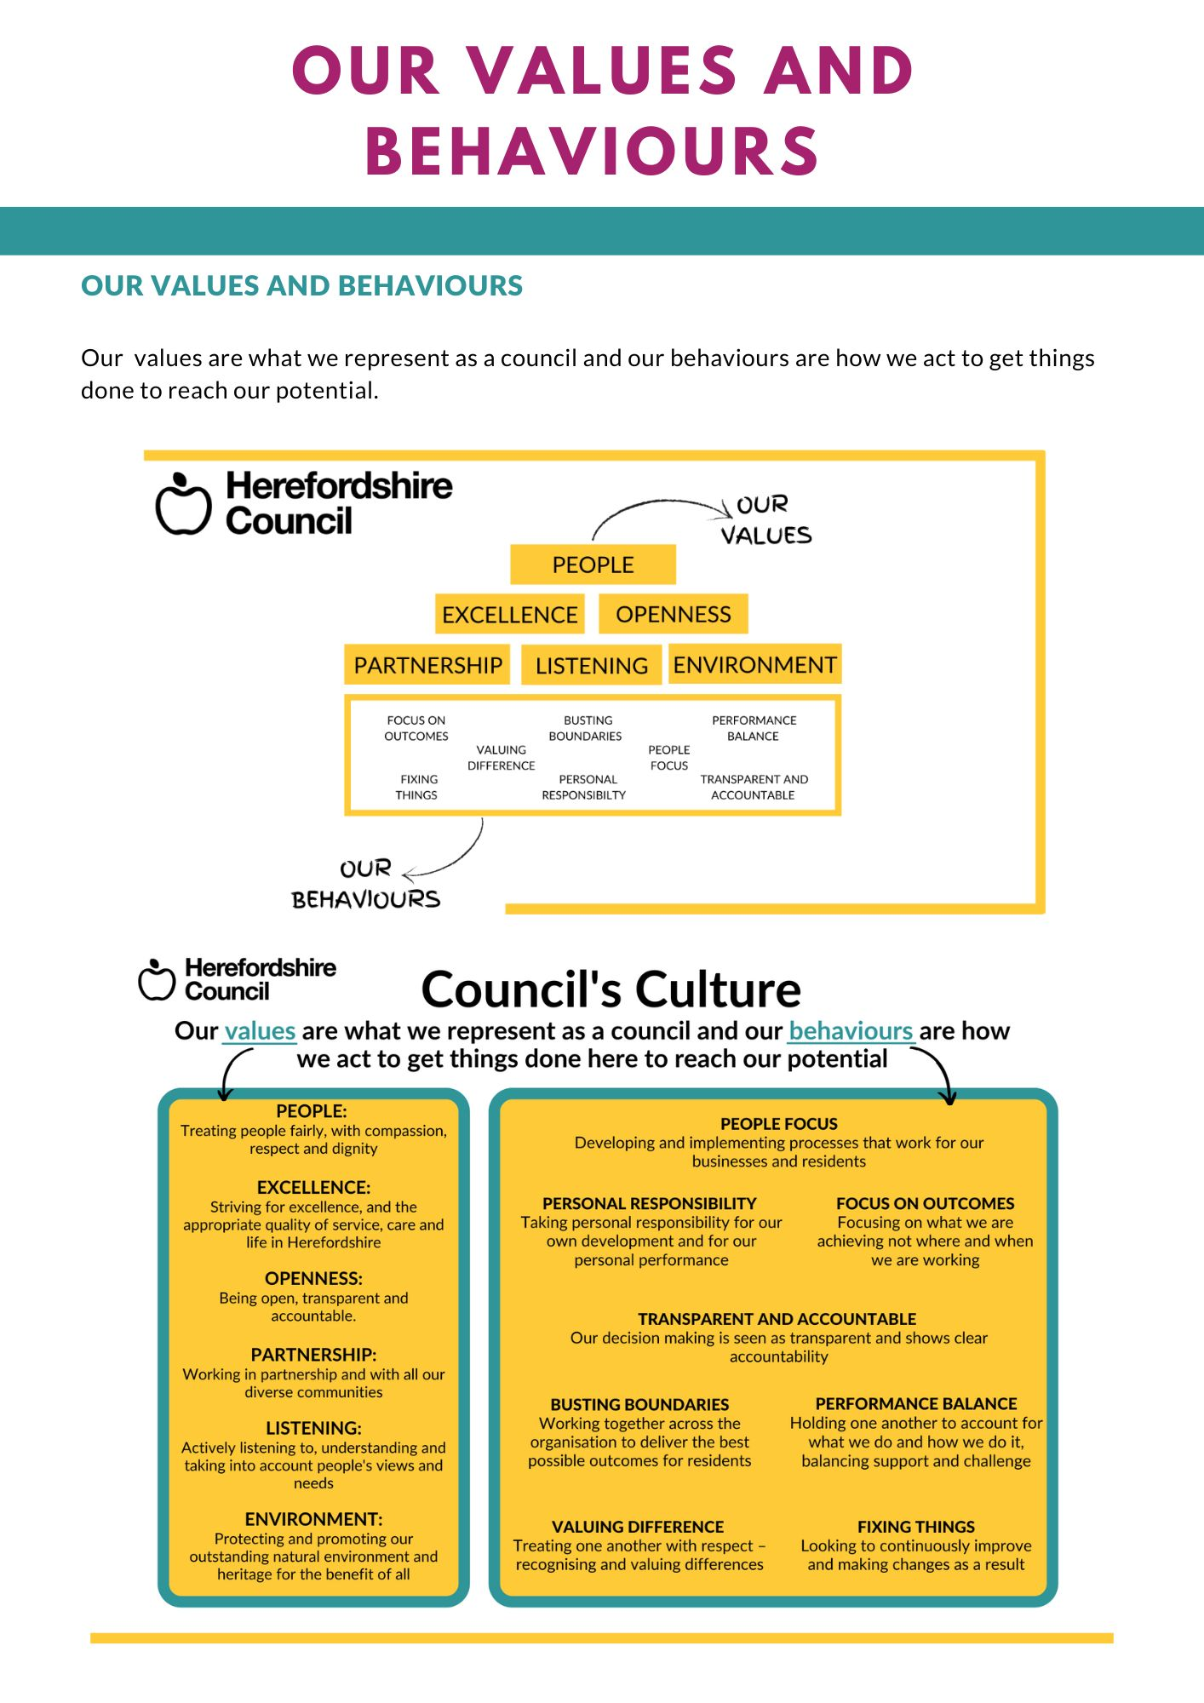
Our values are what we represent as a council and our behaviours are how we act to get things
done to reach our potential.

