Role Structure | Role Details
Directorate: | Children & Young People
Grade: | HC10
Location: | Plough Lane, Hereford
Responsible to: | Team Manager

Job Description

Managing Practitioner
Assessment

Main purpose of the role

The main purpose of the job is to assist the Children’s Social Work Manager with the day to day running and decision making of the team. It includes contributing to the management and effective functioning of the relevant team ensuring appropriate safeguarding and delegation of resources are utilised. Manage a team of social workers to drive performance improvement to achieve excellence as standard.

Key Duties and Responsibilities | Frequency of Task
- Management responsibility for the safe operation of the team. | - Daily
- To provide professional supervision in line with the directorate supervision policy for practitioners within the team as agreed with line manager | - As required
- Ensure that competent professional judgements are made based on evidence, sound assessment and provision for the needs of the child and young people. | - Daily
- Support the Childrens Social Work Manager in quality assurance. | - Daily
- To chair and facilitate meetings commensurate with local and national guidance. | - As required
- To ensure that the work of the team meets required quality standards. | - Daily
- Have awareness of equality and diversity issues as they relate to the role. | - Daily
- To contribute to staff training programmes and service developments across the Directorate. | - As required
- To monitor staff performance and contribute to identifying individual and team learning needs. | - Daily
- Ensure effective outcomes for children and young people are achieved | - Daily
- Maintain continual professional development in social work practise whilst modelling this to other members of staff and promoting a strong learning culture. | - Daily
- Attend relevant external multi-agency meetings to represent the Local Authority to ensure that key professional input and expertise is provided. | - As required
- Role model best practise. | - Daily
- Liaise regularly with peer colleagues throughout the Directorate to ensure social work staff deliver existing and new practices consistently and to a high standard across the Directorate. | - As required
- Deputise for the Children’s Social Work Manager as necessary on oversight and decision making | - As required
- Support and supervise Newly Qualified staff (1st year of practise) and non-social work staff. | - As required
- Performance management of staff. | - Daily
- Chair strategy telephone/meetings and risk management meetings in the absence of a Children’s Social Work Manager. | - As required
- Represent the Local Authority at relevant meetings including MAPPA, MARAC where requested | - Daily
- Undertake and participate in work with regards to Domestic Abuse | - Monthly
- Chair CP Core Group, CIN Planning Meetings and risk management meetings | - When required
- To participate in the recruitment of staff as appropriate | - When required
- To contribute to the professional development of team members | - Daily
- Implement and evaluate the outcomes of social work interventions with children and young people | - Daily
- To provide regular supervision to practitioners | - Monthly
- Allocation of work and cases | - When required
- To ensure that the quality of work meets the required national standards and local procedures | - Daily
- To provide consultation on day to day practice on professional matters to staff | - Daily
- To support Social Workers in preparing assessments and statements for Court and in attending Court | - Daily
- To keep an accurate record of advice given and decisions taken as a result of consultation and supervision | - Daily
- To actively participate in the development and management of new resources to meet identified needs | - Daily
- To allocate work as necessary | - Daily/monthly
- To provide consultation on day to day practice on professional matters to staff | - When required
- To keep an accurate record of advice given and decisions taken as a result of consultation and supervision | - Daily
- To actively participate in the development and management of new resources to meet identified needs | - When required
- Assume responsibility for the professional supervision of staff in a planned and regular manner | - Daily
- To ensure that service provision meets the required standards. | - Daily
- To support the Childrens Social Work Manager to develop strong cross agency links and protocols to ensure Working Together is actively adhered to and services developed | - Daily
- To ensure that staff are kept fully informed of Departments and national policy and objectives, operate within them, and are given the opportunity to influence them through regular staff team meeting | - Daily
- To implement staff performance conversations, identify the training needs of team members and contribute to the training programme of the Directorate | - Weekly
- To have responsibility for paper and electronic records and to provide statistical information to the children’s social work manager as required for monitoring and service planning | - When required
- To attend management meetings in the absence of the children’s social work manager and participate | - When required
- To develop and keep up to date specialist knowledge and skills relevant to the specific remit of their team, attending relevant training courses and staff development programmes as required. To keep informed of relevant national developments and guidance for their area of responsibility | - When required
- To support the service in service planning and development | - When required
- Any other duties as required by the children’s social work manager commensurate with the nature of the job and level of responsibility | - When required
- To deputise when required for the children’s social work manager | - When required

Person Specification

Requirements | Essential or Desirable | Identified by  A – Application I – Interview
Qualifications and Training
- A recognised professional social work qualification (degree or equivalent) | Essential
- Evidence of continued personal and professional development e.g. portfolio of CPD evidence | Essential
Experience & Knowledge
- Extensive post qualification social work experience | Essential
- Experience of mentoring and/or supervising the work of others. Knowledge of theories relating to development, supervision and training, management of change and their application | Essential
- Detailed knowledge of relevant legislation and practice guidance, in particular the statutory responsibilities of a registered Social Worker | Essential
- Experience and commitment to the use of IT systems and communication tools | Essential
- Proven knowledge of thresholds, assessment principles and their application | Essential
- Experience of being involved in a performance management culture and the ability to operate a performance management framework | Essential
- Planning and delivering services to agreed priorities and timescales | Essential
- Extensive knowledge and experience of safeguarding children | Essential
- Experience of working in partnership with other agencies | Essential
- Evidence of managing and resolving conflict in a work setting | Essential
- Experience of recruitment and assessment processes | Essential
- Experience of working within a Children Social Work team | Essential
Skills and Abilities
- Excellent written and verbal communication skills | Essential
- Excellent record keeping skills | Essential
- Ability to prioritise workload, the needs of children and their families within the resources available to the team | Essential
- Ability to lead and motivate a team | Essential
- Able to demonstrate well developed knowledge and specialist skills in relevant areas of social work practice | Essential
- Ability to nurture working relationships across professional boundaries | Essential
- Ability to practice from a strong equality and diversity, ethic and value base | Essential
- Ability to implement staff performance conversations, identify the training needs of team members and contribute to the training programme of the directorate | Essential
- Skills in mediation, negotiation, managing conflict, managing change and teamwork | Essential
- Skills in assessment, planning and a broad range of intervention techniques | Essential
- Time management skills | Essential
- Ability to make effective decisions in a timely manner | Essential
- Ability to plane and manage own workload to agreed targets and to maintain accurate and accessible records | Essential
- Knowledge of current legislation and guidance on services for children and young people including child protection / assessment | Essential
- Commitment to own continuing CPD | Essential
Other Factors
- Current registration as a Social Worker | Essential
- Current enhanced clear DBS | Essential
- Willing to work flexible hours to meet the needs of the service | Essential
- Commitment to involving service users and carers in assessments and evaluation of intervention and services | Essential
- Ability to travel freely in and out of the county | Essential

All council staff have a duty to promote the welfare of children, young people, and adults with care and support needs at risk of abuse and neglect who cannot take steps to protect themselves. Ensuring you attend mandated safeguarding children and safeguarding adults training to enable you to recognise the concerning behavior, know how to talk about it, and consent/duty to share information effectively. You will also learn about the legalities and procedures the social care staff can take.

Our Values and Behaviours

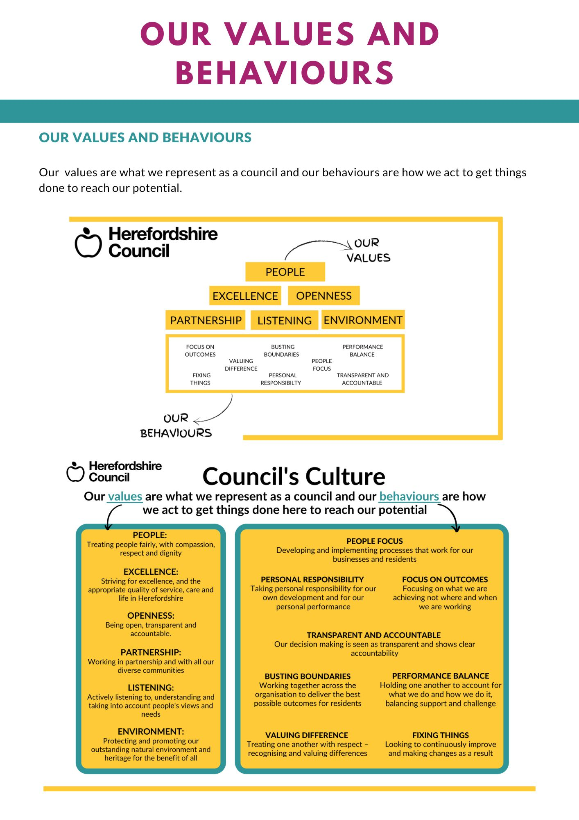
Our values are what we represent as a council and our behaviours are how we act to get things
done to reach our potential.

