Role Structure | Role Details
Directorate: | Community Wellbeing
Grade: | HC06
Location: | Countywide
Responsible to: | Talk Community Health and Wellbeing Manager

Job Description

Job Role: Talk Community Health & Wellbeing Trainer
Service: Talk Community

Main purpose of the role:

Working within a community setting this role will work directly with individuals and groups of people to develop healthier behaviour and lifestyles. The main focus of the role will deliver stop smoking support across the county identifying and working with vulnerable groups and those with the greatest health inequalities and work as part of and alongside other Talk Community and public health initiatives across Herefordshire.
Ensuring that the ethos and approach of Talk Community is delivered and the programme of work is achieved to enable innovation to make independence and wellbeing for Herefordshire citizens inevitable.
They will offer practical tools and techniques, advice, knowledge and encouragement to enable and motivate people to change behaviours (stop smoking) and achieve better health choices and goals for themselves, their families and the wider community.
And will involve developing and sustaining wider community participation and responsibility for improved health outcomes.

Key Duties and Responsibilities | Frequency of Task
To engage with individuals in local communities with identified health inequalities:  - identify, make contact and work with people within the local community;  - work with existing groups and support the development of new groups in order to identify and engage with individuals;  - Deliver group sessions on behaviour change and health improvement, with a focus on stop smoking.  - develop and maintain relationships with individuals who are experiencing the greatest inequalities in health;  - promote the equality and value the diversity of individuals;  - Build and maintain contacts with the community. | - Daily  - Daily
To communicate with individuals and groups about health and health improvement:  - provide information about health and wellbeing;  - provide innovative ways of improving health and wellbeing  - provide information about the relationship between behaviours and health;  - enable individuals and groups to develop their knowledge and skills about health and wellbeing;  - Signpost individuals to other agencies for information, support and resources. | - Daily
To enable individuals to change their behaviour to improve their health:  - help individuals identify how their behaviour and context might affect their health and wellbeing;  - help individuals develop a personal health plan to make the changes they want to make;  - support individuals in achieving their personal health plan;  - support individuals in maintaining their behaviour change;  - help individuals to access and use local services | - Daily
- As part of the Talk Community team establish relationships and work with existing community groups to help them develop healthier behaviour and lifestyle programmes and activities | - Daily
- Work within a Primary Care Network to align with health and social care colleagues to deliver a community based offer | - Daily
- Work alongside the Talk Community development and delivery team to update the community intelligence and share information. | - Daily
- Identify opportunities to work with community based groups to tackle health inequalities and achieve health improvement | - Daily
- To recruit, train, support and empower partner organisations and volunteer health champions to work within the community | - Weekly
- Deliver group sessions on behaviour change and health improvement. | - Weekly
- Align and support the Talk Community hubs and projects | - Daily
- Promote healthy lifestyle to individuals groups of people, helping them set up peer support and community based groups and for their lifestyle change behaviour goals | - Weekly
- Recruit, select and provide ongoing support and training to partner organisations and Health Champions in the PCN’s ensuring a registration of their training status and assessing their competency. Developing and delivery a ‘train the trainer’ model around smoking cessation. | - Weekly
- Communicate any information / issues identified through community engagement that could inform improvements in public health within Herefordshire | - Weekly
- Work with PCN based partner agencies and other public and third party organisations to promote Healthy Lifestyles and healthier behaviour | - Weekly
- Deliver training, act as assessor and mentor for Health Champions (upto RSPH Level 2 and level 3 City and Guilds) along with other continuous professional development of health trainers and volunteer health champions | - Weekly
- Collect activity based health data; ensuring that information and data is collected and recorded accurately thus enabling the production of reliable analyses and reports. | - Monthly
- Work closely with the other members of the Talk Community team to co-ordinate work, share practice and activities | - Weekly
- Develop referral routes into and out of the service as agreed with service manager | - Monthly
- To follow the relevant procedures for ensuring that information and data is collected and recorded accurately thus enabling the production of reliable analyses and reports. | - Monthly

Person Specification

Requirements | Essential or Desirable | Identified by  A – Application I – Interview
Qualifications and Training
- Qualification in supporting healthy lifestyle behaviour change e.g. Health Trainer/ Health Coach or willingness to undertake and complete within a set timeframe | Desirable | A, I
- Willingness to undertake further training where required | Essential | A, I
Experience & Knowledge
- Identifying and working with community based groups | Essential | A, I
- Promoting and advocating changes in behaviour and healthy lifestyles (stop smoking, weight management, increasing physical activity, reducing alcohol) | Essential | A, I
- Providing advice, support and encouragement to individuals and groups in order to improve their health outcomes | Essential | A, I
- Assessing and tackling inequalities in health | Essential | A, I
- Developing relationships and working with external agencies and organisations including community and voluntary groups. | Essential | A, I
- Leading or participating in Talk Community/Public health related project activity or initiatives | Essential | A, I
- Reviewing and evaluating the effectiveness of community based activity | Essential | A, I
- Delivering against service targets | Essential | A, I
- Training staff/volunteer health champions through formal presentations and support in the workplace and enabling people to learn | Essential | A, I
- Marketing and advocating healthy lifestyle services and philosophy to local communities, business sector and the professional public and voluntary sectors. | Essential | A, I
Skills and Abilities
- Understanding of inequalities in health and the wider determinants of health. | Essential | A, I
- Multi-agency/partnership working; able to work across organisational boundaries | Essential | A, I
- Personal resilience giving sensitive nature of work with clients who have complex issues and a good understanding of safeguarding. | Essential | A, I
- Influencing/negotiating skills. | Essential | A, I
- Excellent written and verbal communication skills in formal and informal situations to people from the professional clinical sector and to people at a local level from diverse communities. | Essential | A, I
- Strong influencing, conflict resolution skills; a team player able to share ideas and expertise with colleagues | Essential | A, I
- Continuous professional development | Essential | A, I
- Ability to work independently and on own initiative. | Essential | A, I
- Knowledge and experience of using MS Office products. | Essential | A, I

All council staff have a duty to promote the welfare of children, young people, and adults with care and support needs at risk of abuse and neglect who cannot take steps to protect themselves. Ensuring you attend mandated safeguarding children and safeguarding adults training to enable you to recognise the concerning behavior, know how to talk about it, and consent/duty to share information effectively. You will also learn about the legalities and procedures the social care staff can take.

Our Values and Behaviours

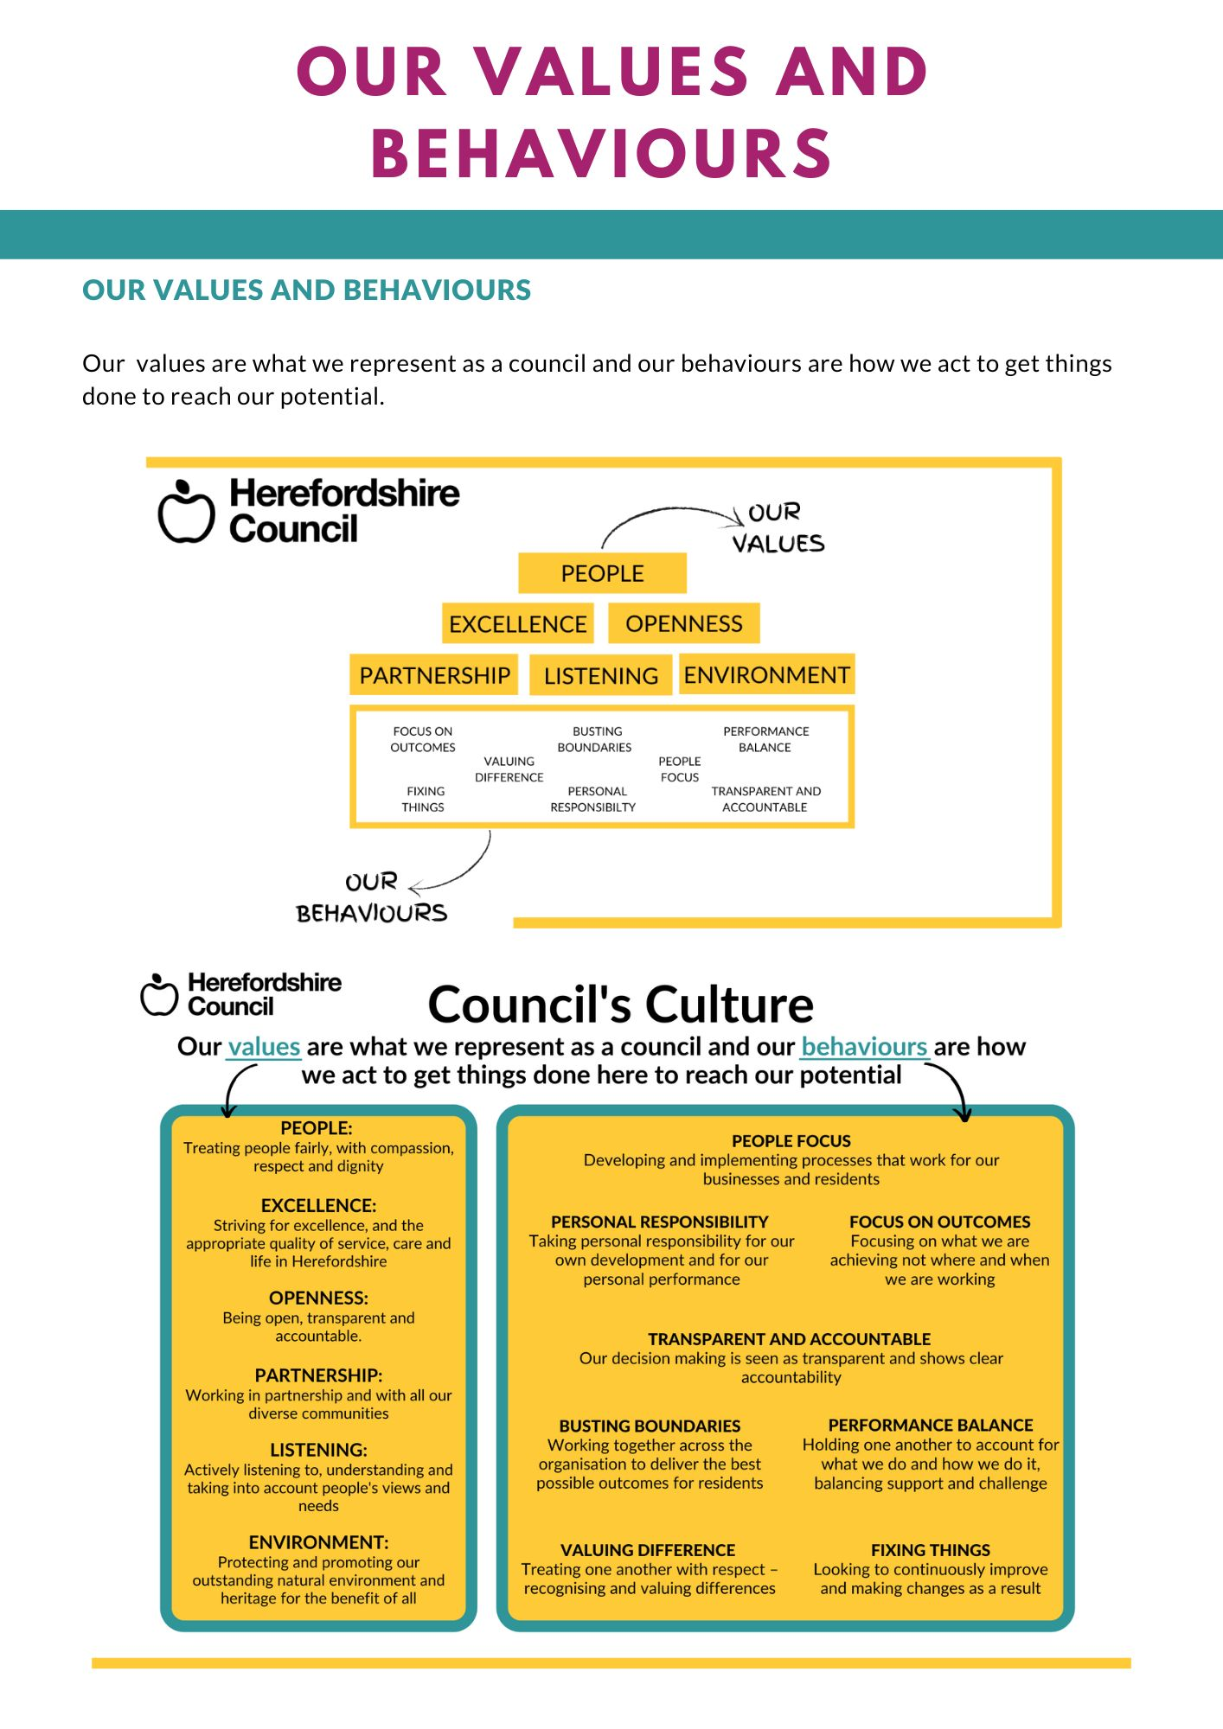
Our values are what we represent as a council and our behaviours are how we act to get things
done to reach our potential.

